**Impact of Operational Modifications in Aluminum Smelting on Bath overflow and Burn-off**

by

**Marwan Albanna**

**May 2023**

# Abstract

Aluminium smelting is a popular technique for the commercial preparation of aluminium. The process involves the production of aluminium from alumina dissolved in molten cryolite. Although the process has been used for years, it suffers various challenges. The significant challenges include bath overflow, anode effect, and current inefficiency, which reduces the yield and quality of aluminium. Therefore, various studies have explored operational modifications to mitigate the anode effects. However, in the proposed study, the yield and quality of aluminium would be evaluated as a function of anode effects and burn-off**.** Therefore, the present study will explore the research question, "Whether modification of cellular parameters or change in smelter design influence metal height, bath overflow, and burn-off attributes in smelting that would provide an estimation regarding the yield and purity of aluminium?" The study is grounded on the notion that improvements in operational conditions positively interact with each other to increase the yield and purity of aluminium.

*Keywords: Aluminium, Smelting, Anode Adjustment, Bath Overflow, Burn-Off, Yield*

**Table of Contents**

1.0. Background 9

1.1. Problem Statement and Purpose of the Study 10

1.2. Project Definition and Goals 12

2.0 Literature Review 13

2.1. Impairments in anode quality and variations in raw materials 13

2.2. Process of Concentration during Electrolysis 14

2.3. Bath overflow problem 15

2.4. Alumina concentrations within the electrolyte bath 16

2.5. Anode Effects in Aluminium Smelting 17

2.6. Possible Solutions on non-consumable anodes 20

2.7. Direct Carbon Thermic reduction 25

2.8. Mind-map 27

2.9. Literature Map 27

2.10. Takeaways from Literature Review 29

3.0. Research Methodology 30

3.1.1. Data set 30

3.1.2. Collab 31

3.2. Bookstores 31

3.3. Methods and computational methodology 32

3.4. Description of Data: 33

3.4.1. Box Plot 33

3.5. Hypothesis testing 35

Chapter 4 – Data Analysis 36

4.1. Data Analysis 36

4.2. Transformation of data 37

4.3. Cell Analysis 37

4.4. Correlation 40

4.5. Covariance 41

4.6. Frequent Transaction Subtype 42

4.7. Time Series analysis and forecasting 61

4.8. Scaling data using box plot 80

4.9. ARIMA Model 96

Chapter 5 – Conclusion 102

5.0. Conclusion 102

**Table of Figure**

Figure 1: (Haraldsson & Johansson, 2018) 21

Figure 2: Mind Map 27

Figure 3: Literature Map 28

Figure 4: Import data from Panda Library 31

Figure 5: NumPy library 31

Figure 6: Matplotlib library 32

Figure 7: Matplotlib library 32

Figure 8: Box Plot 34

Figure 9: Five Number Summary 34

Figure 10 Transformation of data 37

Figure 11: Cell Analysis Details 38

Figure 12 Cell Analysis in detail 39

Figure 13: Cell Analysis in detail 40

Figure 14: Correlation 41

Figure 15: Covariance 42

Figure 16: Metal Tapped Dy Run (kg/pd) 43

Figure 17: Amperage (kA) 43

Figure 18: Curr Eff 7 Dy Running (%) 44

Figure 19: Aluminum (%) 44

Figure 20: Iron (%) 45

Figure 21: Cell Age (days) 45

Figure 22: Cell Restart Age (days) 46

Figure 23: BFT (sec) 46

Figure 24: UF (min) 47

Figure 25: UF_NO (no) 47

Figure 26: Silicon (%) 48

Figure 27: Base RSP 48

Figure 28: Nett Sp Engy 7 Dy Run (kWh/kg AI) 49

Figure 29: Nett Volts per Plot (V) 49

Figure 30: Anode Problem (No) 50

Figure 31: Anode Shift Life (shifts) 50

Figure 32: AIF3 Cons (kg AIF3/pd) 51

Figure 33: Bath temp (oC) 51

Figure 34: Excess AIF3 (%) 52

Figure 35: Metal Ht Bef Tap (cm) 52

Figure 36: ath HT Bef Tap (cm) 53

Figure 37: AE Frequency (AE/PD) 53

Figure 38: AE Duration (Secs) 54

Figure 39: Noise Volts (V) 54

Figure 40: Noise Act (No/pd) 55

Figure 41: Alumina Dumps (No/pd) 55

Figure 42: Lining Drop (mV) 56

Figure 43: Bath Temp (oC) 1 56

Figure 44: AEV (V) 57

Figure 45: SPAR 57

Figure 46: Call Wt (kg) 58

Figure 47: Cruce WT (kg) 58

Figure 48: SM RES 59

Figure 49: TRSP 59

Figure 50: TRSP Time (min) 60

Figure 51: Current Efficiency (%) 60

Figure 52: Net Specific Energy (KWh/Kg AI) 61

Figure 53: NAE Freq (AE/pd) 61

Figure 54: Metal Tapped Dy Run (kg/pd) 62

Figure 55 Amperage (kA) 62

Figure 56: Curr Eff 7 Dy Running (%) 63

Figure 57: Aluminum (%) 63

Figure 58: Iron (%) 64

Figure 59: Cell Age (days) 64

Figure 60: Cell Restart Age (days) 65

Figure 61: BFT (sec) 65

Figure 62: UF (min) 66

Figure 63: UF_NO (no) 66

Figure 64: Silicon (%) 67

Figure 65: Base RSP 67

Figure 66: Nett Sp Engy 7 Dy Run (kWh/kg AI) 68

Figure 67: Nett Volts per Plot (V) 68

Figure 68: Anode Problem (No) 69

Figure 69: Anode Shift Life (shifts) 69

Figure 70: AIF3 Cons (kg AIF3/pd) 70

Figure 71: Bath temp (oC) 70

Figure 72: Metal Ht Bef Tap (cm) 71

Figure 73: Bath Ht Bef Tap (cm) 71

Figure 74: AE Freq (AE/pd) 72

Figure 75: AE Duration (secs) 72

Figure 76: Noise Volts (V) 73

Figure 77: Noise Act (No/pd) 73

Figure 78: Alumina Dumps (No/pd) 74

Figure 79: Lining Drop (mV) 74

Figure 80: Bath Temp (oC) 1 75

Figure 81: AEV (V) 75

Figure 82: SPAR 76

Figure 83: Call Wt (kg) 76

Figure 84: Cruce Wt (kg) 77

Figure 85: Sm RES 77

Figure 86: TRSP 78

Figure 87: TRSP (min) 78

Figure 88: Current Efficiency (%) 79

Figure 89: Net Specific Energy (kWh/kg AI) 79

Figure 90: NAE Freq (AE/pd) 80

Figure 91: Metal Tapped Dy Run (kg/pd) 80

Figure 92: Amperage (kA) 81

Figure 93: Curr Eff 7 Dy Running (%) 81

Figure 94: Aluminum (%) 82

Figure 95: Iron (%) 82

Figure 96: Cell Age (days) 83

Figure 97: Cell Restart Age (days) 83

Figure 98: BFT (sec) 84

Figure 99: UF (min) 84

Figure 100: UF_NO (no)n m,l;ko 85

Figure 101: Silicon (%) 85

Figure 102: Base RSP 86

Figure 103: Nett Sp Engy 7 Dy Run (kWh/kg AI) 86

Figure 104: Nett Volts per Plot (V) 86

Figure 105: Anode Problem (No) 87

Figure 106: Anode Shift Life (shifts) 87

Figure 107: AIF3 Cons (kg AIF3/pd) 88

Figure 108: Bath temp (oC) 88

Figure 109: Excess AIF3 (%) 88

Figure 110: Metal Ht Bef Tap (cm) 89

Figure 111: Bath Ht Bef Tap (cm) 89

Figure 112: AE Freq (AE/pd) 90

Figure 113: AE duration (sec) 90

Figure 114: Noise Volts (V) 90

Figure 115: Noise Act (No/Pd) 91

Figure 116: Alumina Dumps (No/pd) 91

Figure 117: Lining Drop (mV) 92

Figure 118: Bath Temp (oC) 1 92

Figure 119: AEV (V) 92

Figure 120: SPAR 93

Figure 121: Call Wt (kg) 93

Figure 122: Cruce WT (kg) 94

Figure 123: SM RES 94

Figure 124: TRSP 94

Figure 125: TRSP Time (min) 95

Figure 126: Current Efficiency (%) 95

Figure 127: Net Specific Energy (KWh/Kg AI) 95

Figure 128: NAE Freq (AE/pd) 96

Figure 129: Calculation Equation 97

# Chapter 1: Introduction

## 1.0. Background

Aluminium smelting refers to extracting aluminium from its oxide alumina through the Hall-Heroult process (Kvande & Drabløs, 2014). Alumina is extracted from its ore bauxite by using the Bayer process. Since this is an electrolytic process, a considerable amount of electricity is required for aluminium smelting. For this reason, aluminium smelting is carried out near large power stations to reduce the cost of production and carbon footprints. The quality of aluminium extraction smelting depends on various factors, including cellular (the technical attributes of the smelter) and operational (those controlling bath overflow and burn-off).

Burn-off and bath overflow indirectly affects each other. Bath overflow occurs when the liquid bath inside the smelter (furnace) comes out, while burn-off occurs when the anode cube is destroyed inside the furnace. For example, the black cube (prebaked carbon), instead of settling on the top to conduct electricity, falls inside the liquid bath and metal. As a result, the liquid bath and metal inside the furnace will have limited space; therefore, they would overflow outside the furnace; in addition, once it falls, this giant carbon cube destroys the aluminium purity by creating aluminium carbide.

Therefore, anode adjustments such as lowering or raising it could influence the yield parameters of aluminium (Halpin & Seger, 2013). When lowered, the conduction of electricity will be much better. Still, some pieces of the previous anode floating above the liquid bath/metal would be attached to the anode, and if this occurs, it will create the so-called "anode problem" (Galasiu et al., 2007). There are different stages of the anode problem, such as spike to vertical split, horizontal split, and the most problematic of all, if it reaches the burn-off stage because this, in turn, will affect the metal purity and cause bath overflow.

Burn-off is also considered an anode problem. It is separately considered as an operational condition in this study because the effects of the burn-off are much worse than other anode problems. If the anode were raised in the anode adjustments, the current flow would be less, producing less metal. To compensate for it, the power needs to be increased. If the power is increased, the production cost will be more. If the anode is raised too much, we will have an open circuit, which means that the current will not go inside the smelter (giant electric furnace) but will try to seek another place with low resistance, which will put the technicians in danger. This finding suggests that it is necessary to undertake anode adjustments to prevent overflow and the admixture of aluminium with aluminium carbide. These reactions would reduce the purity of aluminium and its yield. This is because prebaked carbon blocks are used as the anode.

## 1.1. Problem Statement and Purpose of the Study

Most of the process control systems related to operational modifications are based on cell voltage because other parameters cannot be measured continuously due to the aggressive medium of the cell (White et al., 2012). When fluctuations (noise) or rapid changes in voltage are detected, the control system should be sensitive enough to detect such changes and analyse the same appropriate actions. These actions include the activation of aluminium feeders and controlling the position of the anode concerning the cathode. However, the complex and interactive nature of smelting conditions and cell parameters make it easier to maintain the yield and quality of aluminium if automated or stringent manual controls are implemented. In this regard, automated software systems are designed to identify and control cell parameters.

Nevertheless, the role and experience of the operator, especially in managing burn-off and bath overflow conditions, cannot be neglected under any circumstances. The alumina concentration, the space between the anode and the cathode, the temperature of the cell, and the electrolyte composition, influence the cell voltage within the smelter. It includes the additives, the depth of the metal pad, the amount of sludge formed inside the cell, the evolution of undissolved material in the electrolyte, anode problems, burn-off, and bath overflow. This finding suggests that anyone parameter related to smelter design or smelting conditions would influence the yield and production of aluminium.

Studies suggest that human expertise and automation of the smelting process could increase the current efficiency up to 97%, which is above the standard operating conditions that exhibit a current efficiency of 95% even under optimum conditions (Prasad, 2000). From this perspective, it could be assumed that other parameters apart from voltage assessment or amperage should be devised for assessing the yield and purity of aluminium during the aluminium smelting process. Although various studies have explored modifications in operational conditions as a function of anode effect or current efficiency, the present study aims to incorporate parameters such as metal height, bath overflow, and burn-off in assessing the yield and purity of aluminium produced by the HH process.

The need to identify such endpoints is to take proactive measures before an anode effect has already occurred and a reduction in current efficiency is apparent. Therefore, the present study also aimed to assess the extent to which automation should be integrated with manual control to produce aluminium. Therefore, the present study will explore the research question, "Whether modification of cellular parameters or change in smelter design influence metal height, bath overflow, and burn-off attributes in smelting that would provide an estimation regarding the yield and purity of aluminium?" This study is grounded on the theoretical framework that improvements in operational conditions positively interact to increase the yield and purity of aluminium.

The proposed study would also add to our understanding of whether the yield and purity of aluminium could be predicted from the cell parameters individually or based on the plotline. This is because the present study would formulate various regression models for predicting the purity and yield of aluminium, including current efficiency.

## 1.2. Project Definition and Goals

* To evaluate the operational conditions and smelter parameters that lead to bath overflow.
* To evaluate the impact of bath overflow on metal height as a measure of purity and yield of aluminium
* To evaluate the effect of anode pumping (raising and lowering the anode) on burn-off attributes
* To evaluate burn-off and bath overflow in two different types of smelters
* To evaluate the interaction between anode-pumping and burn-off on bath overflow and metal height.
* To estimate the current efficiency of the smelters with changing design and anode adjustments

# Chapter 2: Literature Review

## 2.1. Impairments in anode quality and variations in raw materials

Aluminium is produced by the electrolytic reduction of aluminium oxide dissolved in molten cryolite. At the same time, the prebaked carbon anode is converted to carbon monoxide. However, aluminium carbide could be formed in the presence of high voltage. Carbon anodes have a unique role in aluminium smelting, and their use is sorted into technologies including Soderberg and prebaked (Jahedi et al., 2009). The quality and operational condition of the anode influence technological, economic, and environmental aspects of aluminium production, while energy efficiency depends on the porosity of the baked anodes. Approximately 10% of the electrical power within the smelter is used to overcome the electrical resistance of the prebaked anode. Carbon consumption is more than its theoretical value because of low current efficiency and non-electrolytic conduction within the smelter.

Impairments in anode quality and variations in raw materials and production parameters also affect their performance and the overall stability of the smelters. Aluminium is well recognized as a raw material for sustainability for the built environment, technology, and modern economy. The ease with which aluminium is smelted and re-melted without losing its durability and original properties allow it to become a high-value recycled metal. The production and use of aluminium is a modern phenomenon compared to that of gold and silver, which have been there since 6000 to 8000 years ago (Tabereaux & Peterson, 2000). Aluminium has been refined for about 200 years. The smelters are prone to disruptive current surges known as the Anode effects.

The anode effect occurs when alumina concentration in the cryolite electrolyte is too low for sustainable cell operations. Electrical resistance within the cell abruptly increases due to the formation of an insulating gas layer on the anode's underside. In this situation, unwanted greenhouse gas emissions from the anodes, such as PFC, CF4, and C2F6.

Electrolysis is carried out in cryolite in the pot (cell), a steel box lined by a refractory thermal insulator. The smelter base is lined with prebaked carbon, while the sides are lined with graphitized anthracite in Coal Tar Pitch. The carbon anodes are made of coke and pitch binder. Although the significant electrolyte is cryolite, further additions are made, among which excess AlF3 (approximately 10 to 12%) and CaF2 (4% to 6%) with the regular addition of alumina. The additives increase the electrolyte's conductivity and lower its melting point from 1011 degrees centigrade to 920 degrees centigrade, reducing the overall energy consumption after controlling for anode loss.

## 2.2. Process of Concentration during Electrolysis

Alumina is added to the cells periodically because its concentration drops during electrolysis. If the concentration drops by two degrees centigrade, the electrolyte cell enters into the anode effect. On the contrary, the additives reduce the solubility of alumina from 15% by weight to 6% by weight, which eventually limits their overall concentration. Coupled with the anode effect, the lack of solubility of alumina and bath overflow could reduce the yield of aluminium. Therefore, the primary endeavour should be to prevent bath overflow and minimize the loss of alumina from the electrolyte mix. On the other hand, overfeeding the cell with alumina could lead to sludge formation under the molten aluminium pad to decrease the electrical conductivity. This time point is referred to as the sick pot.

The voltage drops from -4.5 V to -40 to -60V (Prasad, 2000). With an optimum current density of 1 A square cm2, the total current is 300kA and a voltage of -4.5V. A typical smelter consists of 200 cells arranged in series in two lines. All cells have strong magnetic fields due to the high amperage. Turbulences could arise at the aluminium electrolyte interface when bus bars cannot compensate. These findings suggest that the conditions for smelting could limit the yield and purity of aluminium if operational modifications are not undertaken. Different operational modifications are undertaken to improve the yield of aluminium. For example, electric energy consumption has been reduced from video 50kwh/kg to 14kwh/kg. Improvements are attributed to an increase in pot size as well as increases in thermal efficiency due to the tightening of operating conditions.

Assuming that the energy required for maintaining the cell is at 960 degrees centigrade, the operational energy efficiency is estimated to be 33% only. The amperage drops within the cell are large, further aggravating the potential drop. This is because of the giant gas bubbles formed at the anode due to the anode effect. The carbon dust or undissolved alumina within the bath lowers its electrical conductivity (Kuang et al., 1996). Doping the anode with lithium salt reduces the overvoltage at the anode. Even with the best quality smelters, the yield of aluminium has always followed Faraday's law. These smelters hit a ceiling of 95% to 96%. The principal loss of aluminium is due to its reaction with sodium fluoride to form sodium ions that dissolve in the bath. The sodium is subsequently oxidized by carbon dioxide to form sodium oxide and carbon monoxide (Brisson et al., 2006).

## 2.3. Bath overflow problem

Sodium oxide reacts with aluminium fluoride to form alumina and sodium chloride in the bath. Thus, the dissolved sodium should diffuse inside the metal pad, preventing alumina formation. The sodium ions that are dissolved in the electrolyte could reduce its electric efficiency by reducing the electrical conductivity in the bath. The bath overflow problem would eliminate alumina to reduce the aluminium further. On the contrary, adding lithium fluoride to the bath increases its electrical conductivity and current efficiency.

Bath composition is another attribute that has received wide attention as one of the essential smelting parameters. The evidence suggests that changing bath compositions, which is also a function of changing smelter design, could improve the thermal efficiency of smelting (by lowering the temperature), raising the current efficiency, reducing the chances of overvoltage, improving operational stability, and maintaining ledge (but not forming sludge below the metal pad). Even if there is a slight change in bath composition, it will affect the proper functioning of the cell by either causing the near anode effect or a reduction in optimum alumina concentration. In the proposed study, it is expected that the change in smelter design would also influence the bath composition that would affect the yield of aluminium as may be measured from the height of the metal or extrapolated from the bath overflow characteristics.

In one study, the author showed that the change in bath (percentage weight of NaF/AlF3 from 1.12 to 1.09 reduces path stability by decreasing the solubility of alumina, which results in the formation of insoluble particles. This phenomenon increases the incidence of bath overflow, which could further reduce the amount of alumina. The reduction of alumina would not only reduce the yield of the metal. However, it would also compromise the current efficiency, forming various impurities due to falling the prebaked anode into the bath. This is why cells with high AlF3 are required to maintain a near-constant bath composition. They require careful feeding of alumina through a stringently controlled computer system.

## 2.4. Alumina concentrations within the electrolyte bath

A lower alumina concentration could itself predispose the risk of anode effects that could lead to bath overflow and a further lowering of alumina within the cell. Alumina concentrations within the electrolyte bath are typically kept at 2% to 5%. Aluminium concentration is maintained because lower concentrations would create the anode effect, while higher concentrations beyond the optimum would lead to sludge formation due to insolubility problems. Low bath ratios could increase the current efficiency, which indicates that it is necessary to minimize the formation of NaF or increase the concentrations of AlF3. In this regard, the granular distribution of alumina that is added becomes essential. When the granular distribution of alumina was increased from 82% to 90%, there were significant reductions in the anode effect.

## 2.5. Anode Effects in Aluminium Smelting

The anode effect (AE) is a significant issue in aluminium smelting because it reduces the yield and quality of aluminium. AE is the polarization of anodes during the electrolysis of fused salts, which is associated with a sudden voltage rise and subsequent amperage reductions. The AE primarily stems from the exhaustion of oxygen-containing species at the surface of carbon anodes during aluminium smelting. This leads to the polarisation of the anode. The anode effect also occurs when alumina concentration becomes too low. The anode becomes dewet, and the voltage increases, causing sparking around the anode.

When alumina is depleted, the voltage increases, coupled with an increase in the surface tension of the bath leading to the electro-capillary effect. The high electro-capillary effect results from high anode overvoltage. This mechanism decreases the wetting of the anode, which reduces the bubble contact angle, forming large bubbles. The alumina concentration usually drops to 30% of its average value before AE. Thus, the oxygen-containing ions arrive at the anode at 2/3rd of their regular rate. The voltage is increased at a constant current, or the current is decreased at a constant voltage once the resistive layer is formed at the surface of the anode.

The AE occurs when the anodic current density (ACD) exceeds the critical current density (CCD). The latter is a function of the dissolved alumina's concentration, the anode's dimension, and the amperage. The AE is mediated by electrolyte flow, gas bubble formation, temperature, and anode spacing. The reduction in Alumina concentration causes initial deterioration of the wetting and increased gas bubble coverage that causes the current density to increase at the active parts of the anode leading to the local depletion of alumina to cause the anode effect. Fluorocarbons co-discharged at the anode surface that later form carbon fluoride intermediates that have a solid dewetting effect leading to high voltage and the formation of fluorides. There are various disadvantages to consumable carbon anodes. The overvoltage is about 0.5V, which also creates impurities of carbon particles gradually introduced in the electrolysis process.

If the overvoltage is around 1.2V, fluorine forms a bond with carbon. These compounds exhibit low surface energy, cause more dewetting, and growth of large bubbles. As a result, a continuous film of gas develops in the electrolyte bath and anode during the AE. Different modifications have been undertaken at the anode, for the anode, and the overall bath characteristics to reduce the anode effect. For example, non-consumable anodes have been designed with coke, binder pitch, and paste materials. Lithium compound-based paste materials decrease the overvoltage at the anode by reducing the wettability of the molten bath.

On the contrary, various authors have used electro catalytic dopants on anode reactions and have reported a lower anodic overvoltage of 200 mV. Changing the dimensions of the anode and their relative position could significantly improve the economy of smelters and the smelting process at large. For example, the anodes located downstream and on the pot ends had more burn-offs than the upstream ones. Raising the anode by 4 cm reduced the number of burn-offs. The carbon anodes made of non-consumable material have been a topic of extensive research. The consumable carbon anode used in cells acts as a depolariser that lower the reversible electromotive force by about one volt. However, the high anodic overvoltage on carbon (0.5V versus 1V) offsets the advantage.

Thorstad and Vogt showed repeated lowering and raising of the anodes (also referred to as anode pumping) to mitigate the anode effects of aluminium smelting. The anode effect goes away after a few cycles. The method is quite effective in terms of energy efficiency because it eliminates the problem of overheating and releasing per fluorocarbon gases in the environment. However, the practice has received specific criticisms with the need for exposing new anode surface area while lowering it, a decrease in anode current due to large active anode surface area, and short circuits to the metal pad. The primary goal of anode pumping is to increase the surface area of the anodes.

Carbon anodes are an integral part of the electric circuit used in aluminium smelting. They contribute chemical energy that reduces electrical energy requirements in producing aluminium metal. Carbon anodes might hinder smelting operations; some are related to the quality of anodes, while the rest are related to cell chemistry. The low anode density might cause the physical loss of carbon anodes as falling pieces into the cell. The physical destruction of the anodes could occur from vertical cracking that happens late in the anode cycle, where pieces of the anode fall off into the cell during the processing of the butts.

Similarly, thin butts could result in the flush wash of stubs in the cells. The breakthrough of stubs can occur through thin anodes' working faces. Both of these problems could lead to aluminium contamination during their extraction. Since butt thickness is one of the significant constraints on anode life, there is a direct correlation between low variations in anode density and higher values. Low-density anodes could significantly lower anode life. Reducing anode density would decrease the production cost due to higher anode life. Physical loss of small carbon pieces occurring from the anode surface (dusting) stems from the selective and sub-surface attack of the anode by air or selective areas of electrolyte attack where the anode is of low current density.

## 2.6. Possible Solutions on non-consumable anodes

A possible solution that could be considered would be inert or non-consumable anodes. The anodes are discussed in Haraldsson and Johansson (2018) to offer significant benefits concerning energy, finances, and the environment when considering aluminium electrolysis (granted, the process has to be employed ideally). However, inert anodes have not progressed beyond the test phase, thus cannot be utilized in practical applications (Ming-yin et al., 2021). Issues like extreme heat output, a corrosive electrolyte, and the difficulty of locating conducting or semiconducting materials that do not disintegrate in the electrolyte all make this process a less viable solution to the given issue (Ming-yin et al., 2021).

In the past, no material that could be used in regular electrolytic cells without degrading over time has been discovered. However, cermet’s, metals, and ceramics were the primary classes of materials for inert anodes (Alzamani et al., 2021). Inert anodes are predicted to have a substantially longer lifespan than carbon anodes, resulting in fewer anode replacements (Alzamani et al., 2021). Since no anode modifications are required once, the cell is running, an inert anode with a lifespan equal to that of the cell is preferable (Alzamani et al., 2021). When inert anodes are used, oxygen gas is produced as a by-product that may be sold to offset some of the process's energy and material costs (Chen, 2020). While compared to carbon anodes, the decomposition voltage of alumina when utilizing inert anodes is roughly one V greater.

Alterations to cell design that lower the ACD might counteract the rise in decomposition voltage (Haraldsson & Johansson, 2018). The ACD reduction may need to be more substantial to offer energy gains when inert anodes are used in conjunction with conventional cathodes. Energy savings may be realized using wet table cathodes in conjunction with inert anodes (Haraldsson & Johansson, 2018). Savings on energy costs are another benefit of doing away with carbon anode manufacturing. Using inert anodes, which provide higher insulation, should also result in increased thermal efficiency (Haraldsson & Johansson, 2018).

| Grounded in | Energy saving Potential | Assessment | Source |
| --- | --- | --- | --- |
| Electrolysis and anode production using a direct retrofit | 1 kWh/kg Al or 7% from  the 2001 level | If new or considerably superior cell designs can be created, the potential for change might increase. |  |
| Electrolysis with direct retrofit in a cell with 15 kWh/kg Al | -2.85–0 kWh/kg Al | A shift in probability is possible if new or considerably superior cell designs can be produced. |  |
| Electrolysis with wet table cathodes and inert anodes  . | 2.4 kWh/kg Al during anode production + savings during electrolysis from using wet table cathodes | 14 kWh/kg Al for electrolysis and 2.5–3 kWh/kg Al for anode production as the base case |  |
| Electrolysis with wet table cathodes and inert anodes | 25% | This is a “best estimate.” |  |

*Figure 1: (Haraldsson & Johansson, 2018)*

Dusting is detrimental to cell operations as it reduces current efficiency and increases hazardous work at the plotlines. Dusting is one of the major causes of a spike or mushroom. Some of the measures that could reduce the physical loss of anodes include avoiding dusty anodes is to bake them at sufficiently high temperatures, minimizing the amount of sodium, and prevent bath contamination of the anodes that emerge from the recycling of the butts, covering the anode sufficiently to prevent airborne, and keeping their permeability at acceptable levels. Anode breakage occurs due to thermal shock when the anode is set or late rota. Thermal shock is a significant issue in aluminium smelting because it could cause a near shutdown of plotlines when there is an excess anode consumption (defined as more significant than the theoretical minimum of 0.33t4kgC/kgAl based on the reaction between alumina and carbon anode at 100% current efficiency.

The excess consumption mechanisms include Fairburn (the reaction of oxygen with carbon anode to form carbon monoxide and carbon dioxide), carboxyl attack (reaction of the carbon anode with carbon dioxide generated in the cell to form carbon monoxide), and electrolytic attack in areas with low current density within the anode to produce carbon monoxide. The problem with Fairburn is that it consumes the carbon anode without producing metal. Being an exothermic reaction, it could upset the heat balance within the cell, generate dust, and can detach the anode from the rod. On the other hand, a carboxyl attack is a phenomenon within the pore structure of the anode above the working face and from the anode side.

A specific reaction preferentially attacks the binder carbon in the anode structure generating dust without producing metal. Finally, a low current density on the vertical anode surfaces causes dust and the generation of carbon monoxide. The heat balance within the cell could be compromised by restricting heat flow up the stub due to damage and erosion of the rod component cross-sections. Poor anode geometry is another factor that reduces the production of the metal. This is because any distortion in the anode and rod assembly could posit problems for the cell by affecting the anode-cathode distance and the overall cell performance. Distortion of the anode as bulging of the top or bottom could lead to poor cell performance and baking furnace standards.

Thus, anode failure within the cell could stem from excessive airborne around the stubbles, thermal shock cracking, failure of rod transition joints, and excessive flux wash of the stubs. Over-covering the anode could damage the anode rods, accelerate toe-in, and lead to thermal damage. The anode cover should be uniform to protect against airborne but low enough for air to circulate and keep the yoke arms cool. Although anode properties influence the yield and quality of aluminium, the present study will explore the role of operational modifications (that prevent the anode effect) on the quality and yield of aluminium.

Apart from bath overflow and anode effects, cathode lining is another operational modification that influences the efficacy of the smelting process. The cryolite and alumina melt to form liquid aluminium, a highly corrosive material. Therefore, very few materials could withstand their highly corrosive action and deposition simultaneously. Carbon, graphite, and TiB2 are the electronic conductors of interest used for casual lining. Nevertheless, cathode failure also occurs due to increasing resistance as a function of the penetration of sodium metal into the lining to cause their destruction. The evidence suggests that SiC would be effectively intercalated with the cathode lining to protect the cathode by creating a sidewall. However, sidewall failure could lead to Al4C3 formation.

In addition, another possibility is gas anodes that are characterized by the use of porous anodes. These may be carbon or inert anodes, in conjunction with providing methane to the electrolysis cell through the anode (Haarberg et al., 2016). In aluminium manufacturing, methane is used as a reducing agent in addition to the anode. The use of gas anodes has the potential to bring about the best-case scenario, which is a decrease of the anode carbon consumption by 44% (Haarberg et al., 2016). However, aiming to reduce the overall costs may lead to other issues that do not justify the cost reduction (Kjos et al., 2018).

Gas anodes can dramatically cut energy usage and CO2 emissions and even eliminate PFC emissions (Kjos et al., 2018). Because of its low price, relatively abundant supply, and excellent purity, methane is an appealing fuel source (Kjos et al., 2018). However, gas anodes must be successfully integrated into industrial electrolysis operations. Thought reasons like optimizing anode porosity, graphite structure, gas flow, and reduced amount of cracked methane make it an attractive option.

Another alternative could be choosing carbo-thermic reduction in place of electrochemical reduction. The electrochemical reduction of aluminium conducted in the Hall-Harold process may be replaced with the chemical reduction of aluminium achieved via the carbo-thermic process. Compared to the Hall-Harold process, the carbon-thermic reduction can reduce energy and enhance the work completed (Li et al., 2020). Some core issues hinder the application of this approach in a professional setting, like extreme operational conditions, yield problems, the creation of aluminium carbide, and extreme heat (Li et al., 2020).

Furthermore, the process also leads to energy distribution for achieving the temperatures, aluminium volatiles, the formation of undesirable by-products, and the complicated back-reaction (Li et al., 2020). These issues pertain to direct carbon-thermic reduction. It is necessary to acquire more understanding of the reactions and kinetics of alumina reduction to find a solution to these issues (Haraldsson, & Johansson, 2020). Indirect carbon-thermic reductions are another area that needs further research and improvement. In addition, Li et al. (2021) found that the Hall-Harold process required a lower amount of theoretical energy, whereas the carbochlorination approach required a more significant amount.

## 2.7. Direct Carbon Thermic reduction

Direct carbothermic reduction begins with the conversion of alumina to aluminium carbide, followed by the aluminium carbide reduction by alumina (Li et al., 2021). The final product is metallic aluminium. It is possible to employ temperatures ranging from around 1900 °C to 2030 °C for the first step. The temperature during the second stage might range anywhere from around 2000 °C to 2130 °C (Li et al., 2021). This cascade of reactions can provide aluminium yields of up to 67%. Some businesses are still developing the carbothermic reduction process (Li et al., 2021), intending to increase the yield. Either developing specific reactors can accomplish this with more advanced vapour management and improved thermal efficiency or by developing alternative chemical routes, such as the high-temperature route (2100–2400 °C) (Li et al., 2021). Carbide formation may be prevented using the high-temperature method, resulting in aluminium yields reaching as high as 90 per cent (Li et al., 2021).

When comparing the Hall-Harold process to the carbothermic process, the Hall-Harold method results in lower carbon consumption overall, while the carbothermic process has more significant specific GHG emissions (Fini et al., 2020). However, when the PFC emissions produced because of the anode effect during the Hall-Harold process are considered, the GHG emissions produced during the carbothermic process are lower than produced during the Hall-Harold process (Fini et al., 2020). The use of electricity has an effect in addition to the total emissions of greenhouse gases. Compared to the Hall-Harold process, the carbothermic reduction requires much less physical area and less relies on economies of scale to succeed. It may be possible to cut manufacturing costs by 25% while simultaneously cutting capital costs by at least 50% (Fini et al., 2020). It is possible to shift the reduction plants closer to the casting facilities, which enables further energy, economic, and environmental advantages to be realized. This freedom provides flexibility.

Based on the literature review, only a few studies have evaluated the interactive effects of different smelting conditions and plotline parameters for assessing the yield and purity of aluminium. In this regard, the proposed study would aid our understanding of the optimum operational conditions from the perspective of the anode effect and multidimensional problems ranging from changes in bath composition to smelter design.

## 2.8. Mind-map

*Figure 2: Mind Map*

## 2.9. Literature Map

*Figure 3: Literature Map*

## 2.10. Takeaways from Literature Review

From the survey of the relevant literature, it can be concluded that aluminium is widely acknowledged as a raw material contributing to the long-term viability of the built environment, technological advancements, and the contemporary economy. Aluminium is a valuable recyclable metal because it can be easily re-melted without losing its toughness or other qualities. Although gold and silver have been mined and used for thousands of years, aluminium is relatively new. After accounting for anode loss, reduced total energy consumption is achieved by applying additives that raise the electrolyte's conductivity and decrease its melting point between 1011 degrees Celsius to 920 degrees Celsius.

To trigger the anode effect in the electrolyte cell, a decrease of only two degrees Celsius in aluminium content must be permitted to occur. Instead, the solubility of alumina is decreased by the additions from 15% by weight to 6% by weight, which ultimately restricts their total concentration. Lack of alumina solubility and bath overflow may contribute to lower aluminium production and the anode effect.

The top priorities should be keeping the electrolyte bath from spilling over and minimizing alumina loss. However, if alumina is over-supplied to the cell, a sludge will develop beneath the molten aluminium pad, reducing the pad's electrical conductivity and the cell's overall efficiency. The potential drop is made worse by the significant amperage dips inside the cell. This occurs because of the anode effect, which forms enormous gas bubbles at the anode. The carbon particles or undissolved alumina decreases the bath's electrical conductivity. Anodic overvoltage may be mitigated by doping the electrode with a lithium salt.

Aluminium production has never followed Faraday's law, even with the greatest smelters. In the water, sodium oxide and aluminium fluoride react to produce alumina and sodium chloride. So, the metal pad should not produce alumina since sodium will diffuse into it. Due to its negative impact on aluminium production and quality, the anode effect (AE) is a critical problem in the smelting industry. When electrolyzing fused salts, AE occurs when the anodes become polarised, leading to an increase in voltage and a decrease in current flow. When aluminium is smelted, oxygen-containing species at the surface of carbon anodes are depleted, leading to AE.

It is because of this that the anode becomes polarised. The anode effect also kicks in when the alumina content drops too low. Due to the anode drying out and the subsequent rise in voltage, sparks may fly from it. Because of their longer expected lifetime, inert anodes need fewer replacements than carbon anodes. Once the cell is up and running, there is no need to make any changes to the anode. Hence, it is best to choose an inert anode that lasts as long as the cell itself. The employment of inert anodes results in the generation of oxygen gas, which may be utilized to recoup at least part of the resources used in producing the final product. When using inert anodes, the disintegration voltage of alumina is around one V higher than when using carbon anodes. Possible solutions to the increasing decomposition voltage include modifying cell design to reduce the ACD.

# Chapter 3: Research Methodology

### 3.1.1. Data set

It is a data set known as the Anglicism dataset, a collection of usually tabulated data. In general, and in its simplest version, a data set corresponds to the contents of a single database table or a single statistical data matrix, where each column table3 columnists a particular variable, and each row represents a para specifics of the data set in question. The publication of the data sets used in an experiment is key to its reproducibility, and there are public laws and standards of scientific journals that make it mandatory to make them public to avoid bias. There are many sources of datasets, such as Kaggle; Google has a platform to search for datasets, "Dataset Search.”

### 3.1.2. Collab

Colaboratory is a Google research initiative designed to aid in disseminating machine learning teaching and research. A NumPy environment needs no setup and operates fully in the cloud.

***Functioning***

Colaboratory is available free as part of the Google cloud application package. To utilize it, log in to our Google account and either input the Google Collab link directly or go to our Google Drive, hit the "New" button, and then show the "More" menu to,» Colaboratory », which will generate a new notebook.

***Runtime environment***

Each cell is independent, but all the cells in a notebook use the same kernel. The kernel is the underneath and that is in charge of executing our code and returning the result in the cell. Kernel state persists over time, so even though each cell is independent, variables declared in one cell can be used in other cells.

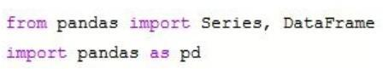

*Figure 4: Import data from Panda Library*

### 3.2. Bookstores

Wes McKinney created Pandas, a high-level data manipulation tool. It is made using the NumPy library, and its primary data structure is known as the Data Frame. The Data Frame enables the researcher to store and modify tabular data in columns of variables and rows of observations.



*Figure 5: NumPy library*

NumPy is Python's virtual library for scientific computing. It includes a high-performance multidimensional array object and utilities for manipulating these arrays.

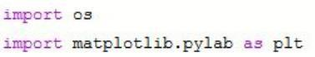

*Figure 6: Matplotlib library*

Matplotlib is a 2D Python plotting package that generates publication-quality figures in various print and interactive formats across all platforms. Matplotlib may be used in Python scripts, the python and ipython shells, web application servers, and six graphical user interface toolkits. Matplotlib attempts to make both simple and complex tasks feasible. With just a few lines of code, the project can create graphs, histograms, power spectra, bar graphs, error plots, scatter plots, and so on.

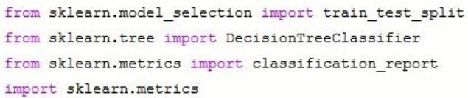

*Figure 7: Matplotlib library*

Sci-kit-learn is an open-source machine-learning package for the Python programming language. It includes various classification, regression, and clustering techniques such as support vector machines, random forests, gradient boosting, k-means, and DBSCAN. It is meant to work with Python's numerical and scientific libraries NumPy and SciPy.

* *Classification: identifies the category to which an item belongs.*
* *Regression: Predicts the value of a continuous property linked with an object.*
* *Clustering: The automatic classification of similar things into groups*
* *Dimensionality reduction: Reduces the number of random variables to take into account.*
* *Model selection entails comparing, validating, and selecting parameters and models.*
* *Pre-processing: Features are extracted and normalized*

## 3.3. Methods and computational methodology

To determine understanding about the yield of aluminium would be assessed as metal height, we used the CRISP-DM model, which comprises six phases: problem analysis, data analysis, data preparation, modelling, evaluation, and exploitation.

* The information source was a Dataset.csv, which was taken from the internet with real data to build a decision tree using the sklearn libraries, and the functions that it offers us where used.
* Analysis of the problem: We identify what types of classification the pages to be tested will have, seeing that there can be three, and we recognize the necessary information to be able to do this classification.
* Data Analysis: with the dataset we obtained, we saw how much information it contains. We classified the linguistic variables in numbers for their correct use with the library that would be worked on.
* Data Preparation: The dataset was cleaned, with the functions provided by the libre, such as eliminating empty fields, and irrelevant data.
* Modelling: We select the appropriate technique to make the classification.
* Evaluation: We had to verify that the chosen model fits what we are looking for, in this case, to classify the aluminium, iron, silicon, etc.

## 3.4. Description of Data:

We have 39 columns. All data numerical data exist in column number one. Its data type is the date used to conduct correlation between numerical data. As we will see in the following graph determined, the correlation between the features. Correlation can be positive value, negative value, or zero. If there is no correlation, the data is based on a positive value if the columns increase together and decrease together. Like the correlation between column ‘Curr Eff 7 Dy Running (%)’ and Date column graph between date and other columns L1 Cell Analysis Detail

### 3.4.1. Box Plot

A box plot is a graphical representation of statistical data that uses the lowest, first quartile, median, third quartile, and maximum values. The name "box plot" refers to how the graph resembles a rectangle with lines extending from the top and bottom.

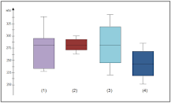

*Figure 8: Box Plot*

Box plots are used to display general response patterns for a group. They are an effective means of visualizing the range and other properties of answers for a big group.

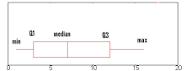

*Figure 9: Five Number Summary*

A boxplot is a method of displaying a five-number summary in a chart. The major component of the diagram (the "box") depicts the interquartile range, which is the middle portion of the data. The first quartile (the 25% mark) and the third quartile (the 75% mark) are located at the box's ends.

## 3.5. Hypothesis testing

The hypotheses that would be tested would be aligned with the objectives and research questions. The tested hypotheses were based on the acceptance of the null (H0) and the alternative (H1) hypotheses, respectively. The hypotheses that would be tested in the proposed study are as follows:

1. **SRQ1: If t**he operational conditions and smelter parameters would significantly influence bath overflow

**H0:** the operational conditions and smelter parameters would not significantly influence bath overflow (p>0.05).

**H1:** the operational conditions and smelter parameters would significantly influence bath overflow (p<0.05).

1. SRQ2: Would bath overflow significantly impact metal height, a measure of the purity and yield of aluminium?

H0: Bath overflow would not significantly affect metal height, which is a measure of the purity and yield of aluminium (p>0.05).

H1: Bath overflow would not have a significant impact on metal height, which is a measure of the purity and yield of aluminium

1. SRQ3: Whether anode pumping (raising and lowering the anode) would have a significant impact on burn-off attributes

H0: anode pumping (raising and lowering the anode) would not have a significant impact on burn-off attributes (p>0.05).

H1: anode pumping (raising and lowering the anode) would have a significant impact on burn-off attributes (p<0.05).

1. SRQ4: Whether burn-off and bath overflow characteristics would vary in two different types of smelters as well as across different plotlines

H0: Burn-off and bath overflow characteristics would not significantly vary in two types of smelters and across different plotlines (p>0.05).

H1: Burn-off and bath overflow characteristics would significantly vary in two types of smelters and across different plotlines (p<0.05).

1. SRQ5: Are there significant interactions between anode pumping and burn-off on bath overflow and metal height?

H0: there are no significant interactions between anode pumping and burn-off on bath overflow and metal height (p>0.05).

H1: there are significant interactions between anode pumping and burn-off on bath overflow and metal height (p<0.05).

1. SRQ6: Are there significant changes in the current efficiency of the smelters with changing design and anode adjustments?

H0: There are no significant changes in the current efficiency of the smelters with changing design and anode adjustments (p>0.05).

H1: There are no significant changes in the current efficiency of the smelters with changing design and anode adjustments (p<0.05).

# Chapter 4: Data Analysis

## 4.1. Data Analysis

One of the usual tasks that every analyst or data scientist faces understands the characteristics of the variables with which they work. Exploring, understanding, and evaluating data quality is a prerequisite for data processing. These actions are necessary to approximate the data before any analysis because many statistical data analysis techniques presuppose the fulfilment of some previous conditions to guarantee the data's objectivity and interoperability. For example, detecting and treating outliers is necessary, given their impact on some statistics, such as calculating the mean.

## 4.2. Transformation of data

The data has been transformed using panda, Matplotlib, seaborne, and NumPy.

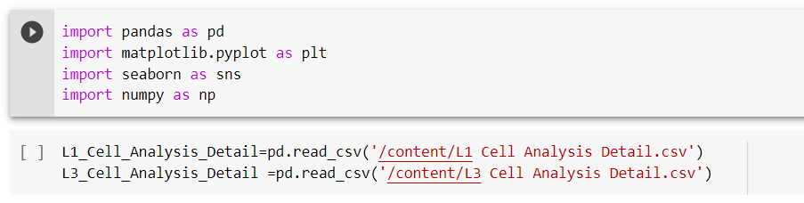

*Figure 10 Transformation of data*

The data has been transformed using four tools on python – pandas, Matplotlib, seaborne and NumPy, the data as entered as cell analysis as it can be seen in figure 4

## 4.3. Cell Analysis

Exploratory data analysis refers to the set of statistical techniques whose objective is to explore, describe and summarise the nature of the data and understand the relationships between the variables of interest, maximizing the understanding of the data set. Regardless of the composition of the data and the statistical analyses that are carried out later. An exploratory data analysis has essential advantages, which include,

* A thorough exploration of the data allows us to identify possible errors (incorrectly entered data, detecting the absence of values ​​or wrong coding variables),
* Reveal the presence of atypical values ​​(outliers),
* Check the relationship between variables (correlations) and
* Their possible redundancy or carry out a descriptive analysis of the data through graphic representations and summaries of the most significant aspects.

Unfortunately, this exploration of the data needs to be more often neglected by data re-users and is an essential part of any statistical analysis for consistent and accurate results.

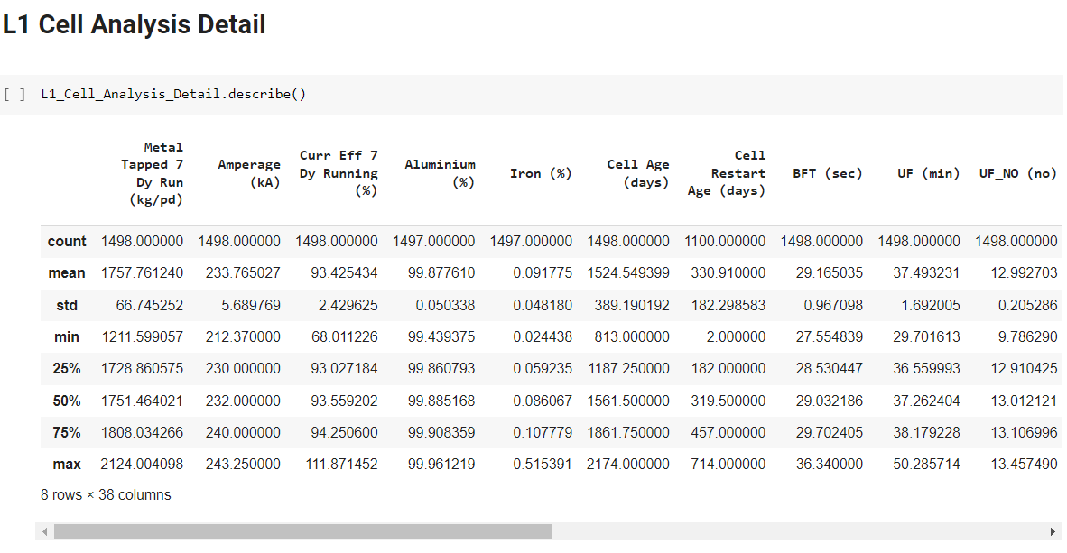

*Figure 11: Cell Analysis Details*

Figure 5 include clear description of data presented entered in python, the figure include a clear descriptive statistics of the values entered for different scenarios such as aluminum, cell age, cell restart age, etc.

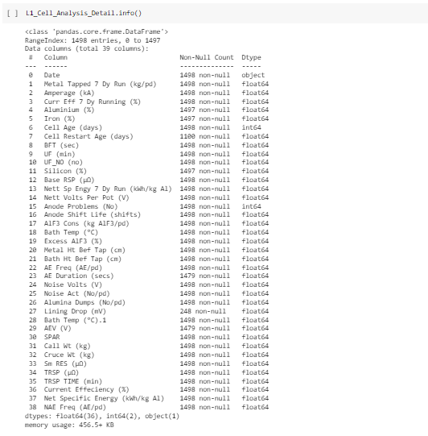

*Figure 12 Cell Analysis in detail*

It present information which include all 38 variables with non-null count and d-type data, they were entered in python so that it can float and the results are extracted easily.

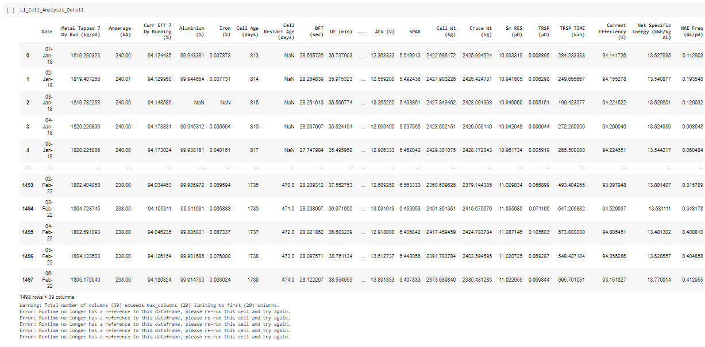

*Figure 13: Cell Analysis in detail*

These software appear as the first development tools intended for the user. Indeed, they proposed, for the problems which can be expressed in the form of results to be calculated by formulas from data, a direct implementation of these results, of these data and of these formulas in a grid of cells visible to the screen.

## 4.4. Correlation

The correlation (R-value, in the graph below) determines the linear relationship between two or more variables: the strength and direction of a possible relationship between variables. In other words, if the values of a variable tend to rise, those of another or other variables will do the same if they are positively correlated or, inversely, negatively. This does not mean that a correlation between variables indicates a cause-effect relationship.

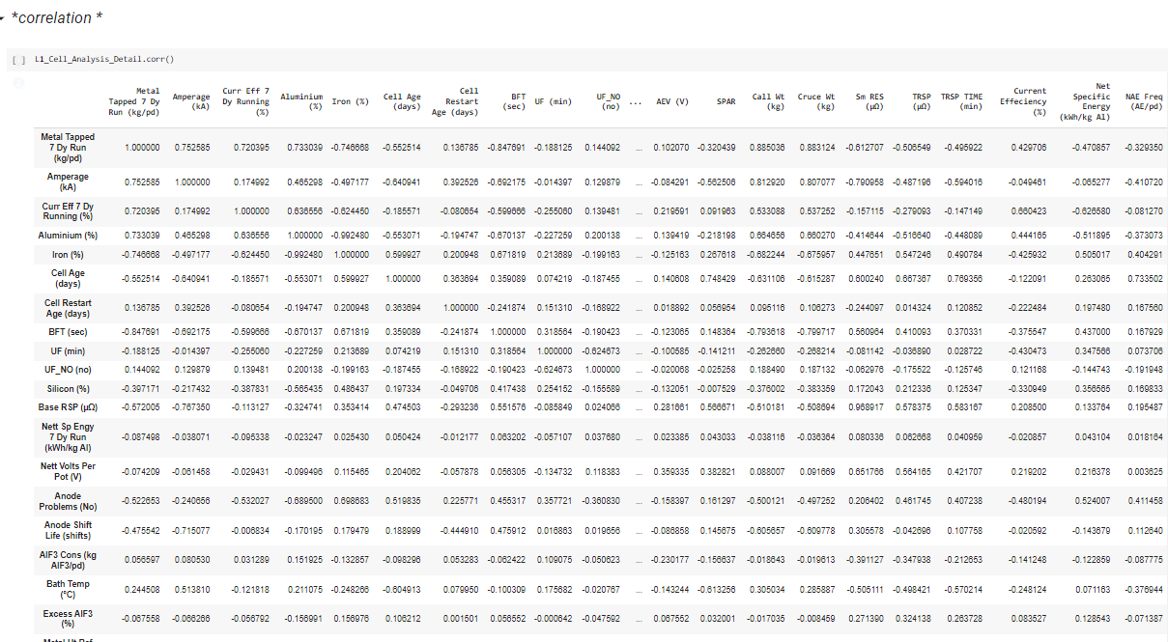

*Figure 14: Correlation*

A strong relationship in a certain sense between two variables could infer information redundancy, and one could be eliminated to reduce the complexity in future data processing and analysis. Without going into the definition of this technique, the correlation is measured through the correlation coefficient "r,” which oscillates between -1 and 1.

## 4.5. Covariance

Covariance measures the relationship between changes in one variable and those in another. It is a measurement of how linearly connected two variables are, specifically. A square matrix that displays the covariance between several separate variables is called a covariance matrix. This might be a helpful technique to comprehend the relationships between the many variables in a data collection. The example that follows demonstrates how to build a covariance matrix.

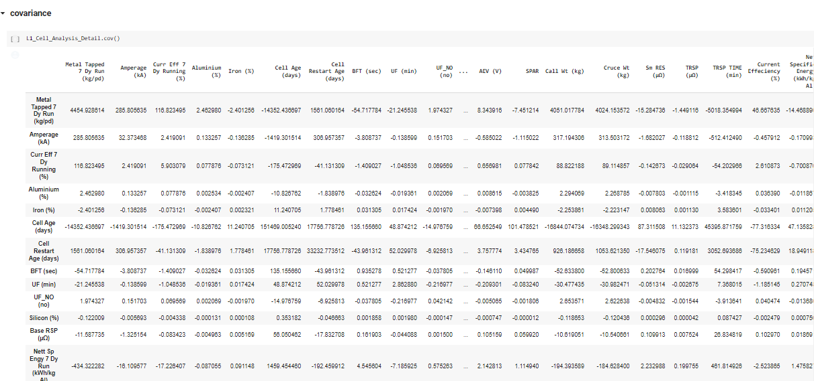

*Figure 15: Covariance*

Two variables tend to rise or fall together when the covariance is positive. For instance, the correlation between math and science is positive (33.2), which suggests that kids who do well in arithmetic also often perform well in science. In contrast, pupils who do poorly in arithmetic also often perform poorly in science.

A negative covariance value means that a second variable tends to decrease as the first grow. For instance, the correlation between arithmetic and history is negative (-24.44), meaning that children who do well in math often perform poorly in history. In contrast, kids who do poorly in arithmetic often perform well in history.

## 4.6. Frequent Transaction Subtype

The concept of subtype is presented to be able to use an existing attribute but change its name. A series of Data store operations on one or more entities constitutes a transaction. Transactions are never partly applied since every transaction is guaranteed to be atomic. Either all of the transaction’s activities are applied, or none is with a 10-second idle expiry period after 30 seconds. Transactions may last up to 60 seconds. The results optioned for the frequent transaction subtype are,

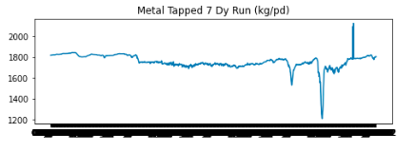

*Figure 16: Metal Tapped Dy Run (kg/pd)*

For this section, frequency transaction subtype has been taken into consideration; it is a type of graph, which shows frequency and relationship between the data selected for a project. The above graph shows that the metal-tapped seven Dy Run has seen fluctuation, the majority of the reason states at 1800, which dropped to 1400, and later achieve steady growth rate in the burning process of aluminium.

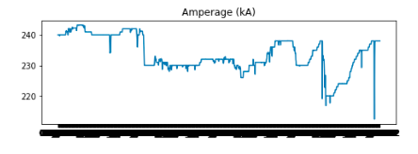

*Figure 17: Amperage (kA)*

Amperage in general defines electrical currency measured in amperes and describe the amount used for electrical charge of a machine or system. The undertaken project is about determining the Impact of operational modifications in aluminium smelting on bath overflow and burn-off. Therefore, the above graph has shown the fluctuated frequency of the amperage (KA), the bounce of frequency increases and decreases at a different point, but in the end, it dropped to 220.

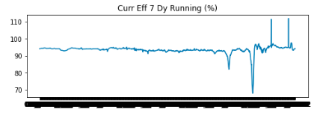

*Figure 18: Curr Eff 7 Dy Running (%)*

An approach naive method for the extraction of frequent patterns consists in scanning the set of all the patterns, calculating their number of occurrences (support) and keeping only, the most frequent ones. The results presented above discusses the efficiency of current for a certain period. The above graph observes a straight line in the frequency trend for Curr Eff 7 Dy Running, it dropped to 70% at a point, but it regained its composure to 110% at the end of the reading.

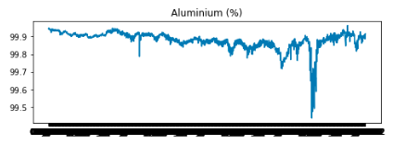

*Figure 19: Aluminum (%)*

The number of patterns present in a database is generally very large; it is common to obtain several million of them. Their use is classically based on a process of selection by frequency in order to keep only the most representative ones. It is an effective pragmatic way of pruning the search space. The percentage at which aluminium burn shows a downside in the ratio. There is a thick downside trend. Hence, it requires further consideration.

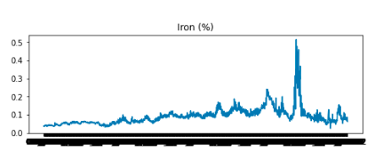

*Figure 20: Iron (%)*

The above graph shows the frequency at which iron responds to temperature; there is an upward trend for a short period. However, overall, the percentage at which the temperature of iron is maintained is stable. This approach turns out to be insufficient in many practical cases and shows its limits when the search space is large or the database very dense and correlated.

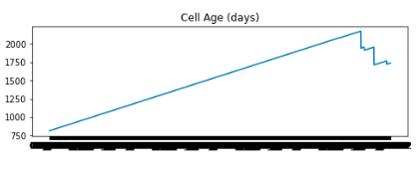

*Figure 21: Cell Age (days)*

Condensed pattern representations provide a solution to the problem of frequent pattern extraction by providing a summary of frequent patterns, while ensuring that the set of frequent patterns can be reconstructed if necessary. The cell age of days is observed to shoot directly from 750 to 2000, and then it goes downwards. The trend line is set based on a straight line showing the high value of the figures included in the cell.

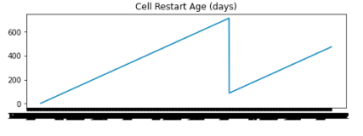

*Figure 22: Cell Restart Age (days)*

The set of association rules can be found by calculating the confidence of all the possible combinations of frequent items and then taking those whose confidence is important. This operation can be accelerated by saving the list of frequent items with their frequencies as it can be seen in the cells. After the cells were restarted, there was a change in trend. The figure starts from zero and boosts to 600, observing a downward trend to 400.

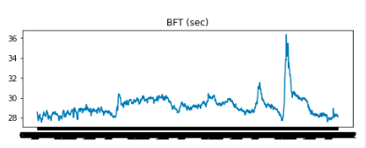

*Figure 23: BFT (sec)*

The above graph represents the relationship between the frequency of appearance of X without Y (error rate of the rule), and the rate of erroneous predictions. Rules that go beyond a minimum of support and a minimum of quality are called solid rules. The frequency at which BFT sec is working has seen growth, and the burn rate has been stable, but it has seen an increase in the end, like other temperature readings.

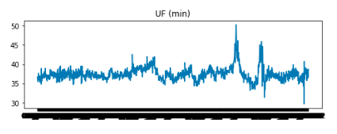

*Figure 24: UF (min)*

The search for such patterns thus consists in extracting sequences of sets of items, commonly associated over a well-specified period. In fact, this research highlights inter-transaction associations, contrary to that of association rules that extracts intra-transaction combinations. The reading of UF (per minute) increases from the start, and the frequency changes are seen upward. However, it reached higher just after 45 min where the reading observed a height

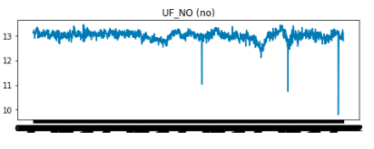

*Figure 25: UF_NO (no)*

Calculation of k orthonormal vectors that provide a basis for the input data standardized, these are unit vectors that each point in a direction perpendicular to the others. These vectors are called principal components. The input data is a linear combination of the principal components. The UF_NO observed in this image s shown a downward trend, and the ratios are seen in a downward trend, which shows a negative value.

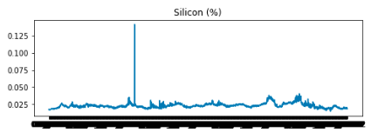

*Figure 26: Silicon (%)*

The principal components are sorted in descending order of importance, that is, the axes sorted are such that the first axis has the highest variance among the data, the second axis shows the next highest variance, and so on. The burnout at which silicon burns is stable, and does not increases above the value of 0.25%. However, it reached .125% at a point, which later reached its current value.

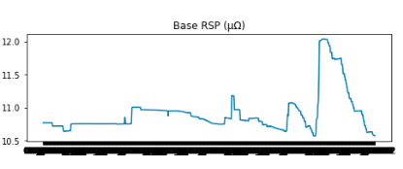

*Figure 27: Base RSP*

As the components are sorted in descending order of "significance,” the data size can be reduced by eliminating the weakest components, i.e. those with low variance. By using the strongest principal components, it should be possible to reconstruct a good approximation of the data of origin. The above graph studies the Base RSP of the cell data, the frequency value sees a stable state, but usually, the number shows a height in the end.

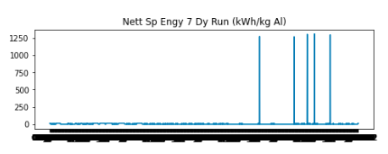

*Figure 28: Nett Sp Engy 7 Dy Run (kWh/kg AI)*

The above graph, "Nett SP Engy 7 Dy Run,” shows a 0 value throughout the reason. However, it has shown an increase at 5 points, reaching 1250. These techniques can be parametric or non-parametric. In parametric techniques, models or functions are used to estimate data. The parameters of the models are alone saved instead of the data an example of these methods is linear regression.

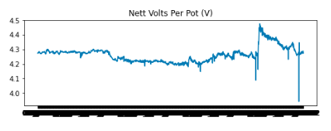

*Figure 29: Nett Volts per Plot (V)*

Here it is guaranteed that the criterion of class amplitude equality is respected, the amplitude being the difference between the greatest value and the smallest value. From the global minimum of the data and the global maximum of the data. The above graph shows Nett Volts per Plot, showing the reading at 4.3 v throughout.

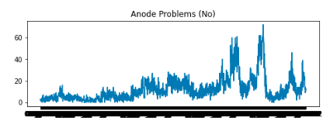

*Figure 30: Anode Problem (No)*

The starting interval is separated in two by taking as the separation value the overall mean of the values. We then start again by dividing each class in two, taking as the separation value the average of the values ​​of the graph. The Anode problem in the above graph shows a thick trend from the start. The reading has been unstable and does not reach a height of 60 until the end, which shows that the actual problem starts at 60 n.

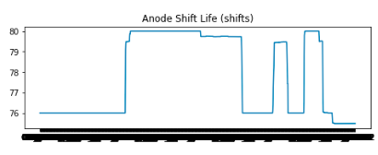

*Figure 31: Anode Shift Life (shifts)*

It is important to sort the values in order increasing then we calculate the differences successive relative values between a value and its next. We change class when the relative difference is greater than an arbitrary threshold, typically 50%. The number of classes is therefore not fixed a priori. The above graph presents a visual presentation of Anode Shift Life, showing that there is uncertainty in the frequency, ups, and downtrends, which shows the nature of data.

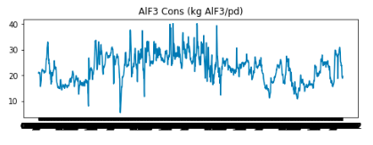

*Figure 32: AIF3 Cons (kg AIF3/pd)*

The results is used to provide qualitative insight into large and complex datasets, summarize data, and help identify regions of interest and appropriate parameters for more focused quantitative analysis. The above graph AIF3 Cons kg ALF3 shows stability in the frequency rate of the data. The data shows that the user has of a validated hypothesis and knows exactly what needs to be presented and focuses on refining the visualization to optimize the presentation.

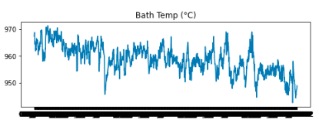

*Figure 33: Bath temp (oC)*

Each data point is represented as a polyline that crosses each axis at a position proportional to its value for that dimension (the endpoints of the axis correspond to the minimum and maximum values for each dimension). The bath temperature of the data shows growth in the temperature of the bath when working with different materials

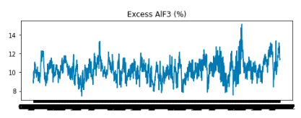

*Figure 34: Excess AIF3 (%)*

The graph shows upright trend in Excess ALF3 of the data. They require structures, and parameters to adjust in very specialized systems such as medical visualizations and network intrusion systems, etc. There are many critical decisions that need to be made throughout this pipeline, such as how to choose the best visualization for a particular domain and task, what forms of interaction should be supported, and how best to 'integrate analysis tools into the visualization.

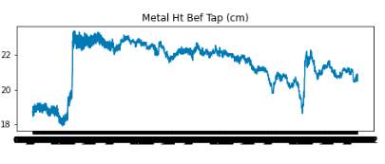

*Figure 35: Metal Ht Bef Tap (cm)*

Frequent patterns are patterns or patterns (such as item sets, subsequence’s, or substructures) that appear frequently in a data set. For example, a set of items such as milk and bread that often appear in a transaction database in operational modifications in aluminium smelting on bath overflow and burn-off, is a frequent set of items. The graph of Metal Ht Bef Tap (cm) starts with a downside trend, but it picked an upward frequency when it raised from 18 cm to 22 cm.

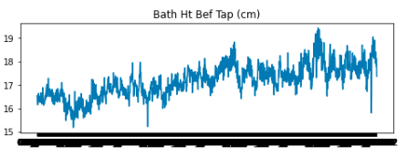

*Figure 36: ath HT Bef Tap (cm)*

A sub-sequence such as first buy a PC then a digital camera then a memory card, which often occurs in the purchase history database, is a frequent sequence of items. Substructures can be sub graphs, which can be combined with sets or sequences of items. The above graph Bath HT Bef Tap shows data rising from 16 cm to 19 cm at the end of the frequency reading.

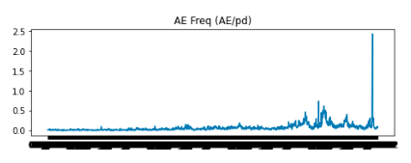

*Figure 37: AE Frequency (AE/PD)*

The basic version of frequent pattern mining allows you to search a table in a relational database whose values are Booleans indicating the presence or absence of a property. Such a database is called a formal database. The above graph shows AE Frequency (AE/PD) from zero value to 0.5 in the end before it picked a pace in the end by 2.5.

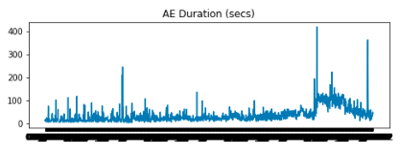

*Figure 38: AE Duration (Secs)*

Unfortunately, this approach is too time and resource intensive. Indeed, the number of patterns is 2p (p is the number of properties), and in practice, we want to handle bases having a large number of attributes. The above graph AE duration (sec) shows frequency starts from 100 secs to 400 secs

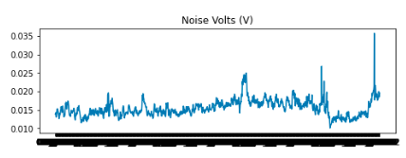

*Figure 39: Noise Volts (V)*

It is traversed by increasing level from of level i = one. When a pattern is infrequent, all its super-patterns are infrequent. In our example c is not frequent (it has been crossed out) and therefore none of its super-patterns is considered. We have thus pruned the course of the trellis. The above graph shows the frequency of data based on noise volts start from 0.015 v to onwards 0.035.

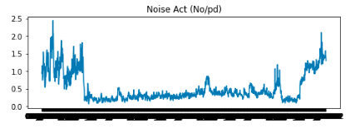

*Figure 40: Noise Act (No/pd)*

This can follow an iterative approach by setting a threshold at the start and, depending on the result, will change the value of the threshold. If too many frequent patterns have been found, it will increase the threshold; otherwise, it will decrease it. There is a huge gap in the frequency of Noise act in the data, there was an upward trend in the start when the data reached 2.5 but the value fell to 0.5, it further raised to 2.0.

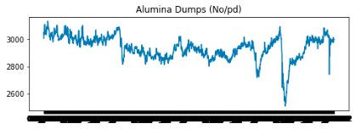

*Figure 41: Alumina Dumps (No/pd)*

The threshold σ is set by the analyst. Moreover, it can be seen that the calculation time of the algorithm decreases with the threshold. Therefore, if the analyst sets a threshold value that is too large, it will waste less time than if he sets one that is too small. The above graph alumina dump seeing a downward trend, the frequency has stability; however, the data need further understanding and clarification.

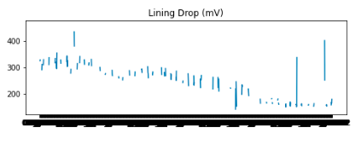

*Figure 42: Lining Drop (mV)*

This formula is of course used with numeric values; it corresponds to the Avg(X) function in python language. One way to speed up the calculation of the average is its distribution: the data set is subdivided into subsets and the average of each subset is calculated independently and in parallel. The above graph lining drop shows clustered images and trend in the figure, there are both upward and downward trends.

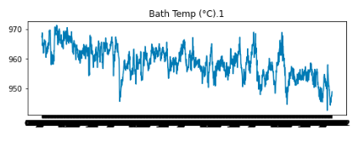

*Figure 43: Bath Temp (oC) 1*

Spread measures the degree to which data is spread over its interval. The measures most used to calculate the dispersion are the rank, the quartiles, the interquartile rank, and the standard deviation. These measures are very effective in detecting extreme data or strange. The above graph shows the bath temperature has started from upward trend of 970 and the temperature is maintained as it can be seen throughout this reading.

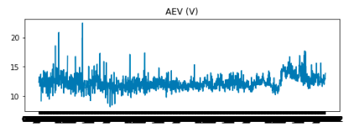

*Figure 44: AEV (V)*

The problem of data disintegration arises when using data from multiple sources: databases of different formats, files, web pages, etc. to build a single database (data warehouse) for analysis. The above graph shows AEV, the changes are frequent and rapid as it can be seen in the data presented in the cell.

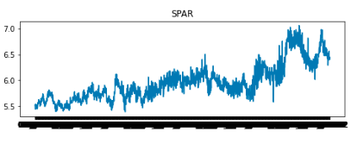

*Figure 45: SPAR*

Transforming data consists of putting them into appropriate intervals for analysis. Many analysis techniques require data to be presented in specific intervals such as [-one, one], [zero, 1], [0, 100]. The frequency of SPAR shows how the temperature starts from 5.5, which increased to 7.0 by the end of the reading.

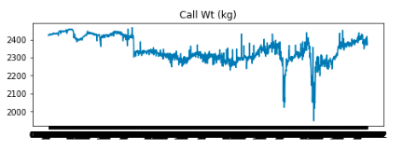

*Figure 46: Call Wt (kg)*

The Pre-processing also includes data reduction, which reduces the volume of data to speed up calculations and represent the data in an optimal format for exploration. Data mining can be very time-consuming on data complete. The above graph shows call wt. in kegs where the weight of the material was 2400 kg before the burnout process started, it dropped at some degree, but regained its composure in the end of the reading.

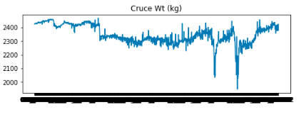

*Figure 47: Cruce WT (kg)*

The goal of attribute selection is to find a minimum set of attributes such that the resulting probability distribution of the data classes is as close as possible to the initial distribution obtained using all attributes. The above graph shows highs and lows in the Cruce WT (kg), the frequency started from 2400 that continued to the end.

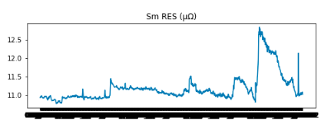

*Figure 48: SM RES*

The procedure starts with an empty set of attributes as the reduced set. The best of the original attributes is determined and added to the reduced set. With each iteration, the best of the original attributes remaining is added to the set. The above graph SM RES’s frequency started from 11.0, which increased, to 11.5 and by the end, it reached 12.5.

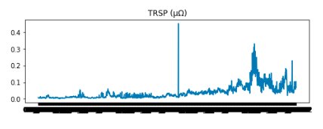

*Figure 49: TRSP*

Among the most widely used methods in this context is principal component analysis (PCA), which consists of replacing the original set of attributes with new ones with maximum variance, uncorrelated pairwise and which are linear combinations of the original variables. These new variables, called principal components serve as the basis for a flat graphical representation of the initial variables. The above graph TRSP shows that the frequency started from 0.0, which increased to 0.3.

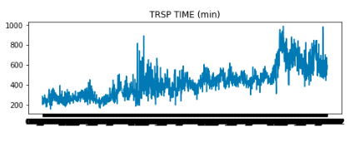

*Figure 50: TRSP Time (min)*

The input data is normalized so that each attribute is in the same range. This step ensures that large scope attributes do not dominate the attributes of smaller extents. The above graph TRSP Time (min) shows the value of frequency starts from 200, which reaches to 1000 mines by the end.

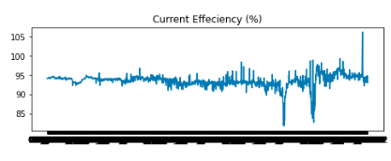

*Figure 51: Current Efficiency (%)*

The usual approach used, to find anomalies in a series, is to create a model of the normal behaviour of the series and then characterize the sub-series, which are too far from the model as anomalies. The datasets to be analysed may contain hundreds or even thousands of attributes, many of which may be unimportant for the analysis or redundant. The above graph currency efficiency shows the data starting from 95%, which rose to 105% by the end of this reading.

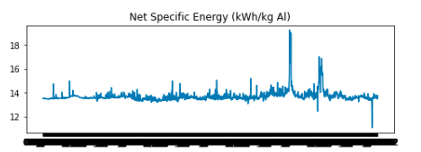

*Figure 52: Net Specific Energy (KWh/Kg AI)*

Clustering can be applied to each time series in an ensemble. The objective is to regroup whole series in groups such as the time series in each cluster are as similar as possible. The above graph Net Specific Energy (KWh/Kg AI) starts from 14 kWh that increased to 18 in the middle of the frequency, the data dropped in the end to 12 KWh.

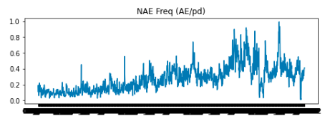

*Figure 53: NAE Freq (AE/pd)*

Clustering on time series can be performed by several approaches to each its own ingredients. For instance, the use of a k-Means type-clustering algorithm on a set of time series raises the questions of the choice of a measure of distance between two time series. The above graph NAE Freq starts from 0.2 that later reached 1.0 at the end of this frequency reading.

## 4.7. Time Series analysis and forecasting

Time series forecasting is the process of making predictions based on data with historical time stamps. It comprises developing models via historical analysis and using them to make judgments and direct future strategic decision-making. An important distinction between forecasting and prediction is that the future outcome is completely unknown at the time of the job and can only be foreseen by careful analysis and evidence-based priors.

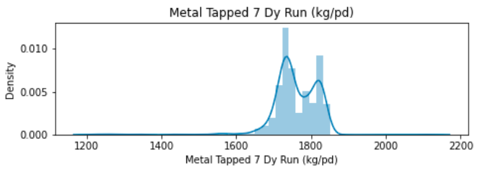

*Figure 54: Metal Tapped Dy Run (kg/pd)*

The graph above demonstrates the variation in the metal that was tapped at Dy Run 7; the bulk of the reasons are given as 1800, which decreased to 1400, and afterwards attain constant growth rate in the burning of aluminium. The variations of the values of two series can occur at different times while preserving the similarity of the series as in the second example of the figure former.

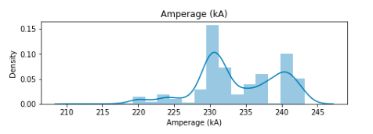

*Figure 55 Amperage (kA)*

The accompanying graph illustrates the fluctuating frequency of amperage (KA). The frequency bounces up and down at various points, but eventually falls to 220. In this approach, clusters are created by extracting subseries from several longer series. It is possible to detect by this approach, for example, the clusters of electricity consumption periods for a given material.

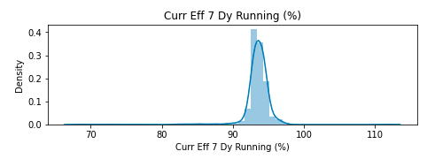

*Figure 56: Curr Eff 7 Dy Running (%)*

The frequency trend for Curr Eff 7 Dy may be seen in the graph above as a straight line. Running, it dipped to 70% at one point, but by the conclusion of the reading, it had begun to recover control and was at 110% the objective is to find a decision model allowing to give the class of a given series based on a set of time series already classified. The same approach followed for supervised classification of the data.

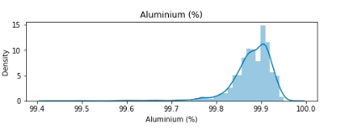

*Figure 57: Aluminum (%)*

A time series, or time series, is a finite sequence of numerical values representing the evolution of a specific quantity over time. Such sequences of random variables can be expressed mathematically in order to analyse their behaviour, generally to understand their past evolution and to predict their future behaviour. There is a thick downward trend in the proportion at which aluminium burns, indicating the needs further thought

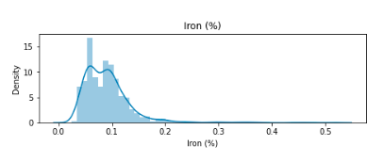

*Figure 58: Iron (%)*

This include extracting certain sequential patterns whose support exceeds a predefined minimum support. The aforementioned graph illustrates how often iron reacts to temperature; although there is a brief rising trend, generally, the percentage at which the temperature of iron is maintained remains steady.

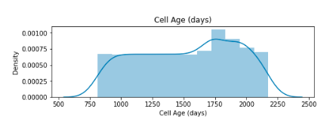

*Figure 59: Cell Age (days)*

Data reduction results represent the game of data, smaller in volume, but which produces the same (or almost) analytical results. The cell age in days is shown to have increased steadily from 750 to 2000 before beginning to decline. The trend line is created using a straight line that displays the cell's high value data.

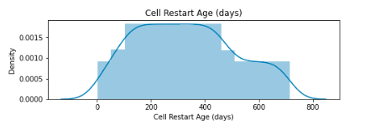

*Figure 60: Cell Restart Age (days)*

Considering the complexity (however relative) of the model compared to what we have encountered so far, it seems useful to us to consider some discussion on the implementation choices and their impact on practical use. After the cells were restarted, the pattern changed; the number increases from zero to 600 before trending downward to 400.

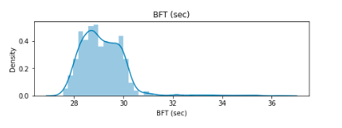

*Figure 61: BFT (sec)*

An example of the application of such clustering is the clustering of companies in order to detect companies whose variations in stock values resemble each other. As with previous temperature measurements, the frequency at which BFT sec is operating has steadily increased, and the burn rate has remained constant.

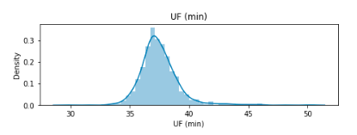

*Figure 62: UF (min)*

The statement explicitly cites quantities that are likely to appear in the model. Before establishing the list of these quantities and classifying them according to their type. The UF reading (per minute) has been increasing from the beginning; the fluctuations in frequency are visible as they go upward, but the reading has just reached its highest point after 45 minutes.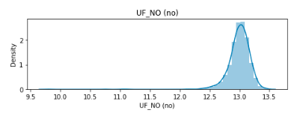

*Figure 63: UF_NO (no)*

The proposed method explicitly excludes models that include recursive rules for processing these models in a procedural language (distinguish between languages that allow recursion from those that do not). The ratios are displayed in a decreasing trend and display a negative value, as seen in the UF NO noticed in this figure

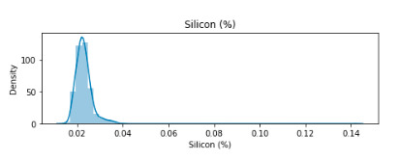

*Figure 64: Silicon (%)*

During implantation in the electronic sheet, a cell is assigned to the quantities B, p, R and N, the latter 2 being defined by calculation formulas derived from the above rules. The rate at which silicon burns is steady and does not rise over 0.25%; although, at one time, it reached.125percentage, before returning to its previous level.

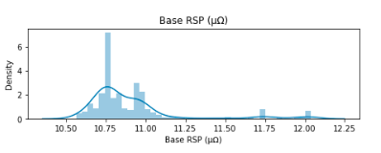

*Figure 65: Base RSP*

The first format explicitly shows each value in the series. Expressions will be placed in columns or rows as for ordinary dimensioned quantities. The graph above explores the frequency value of the cell data's base RSP indicates a steady condition, but often the number ends up showing a height.

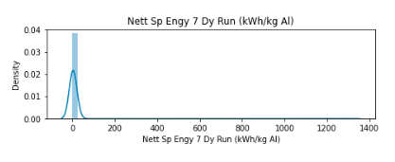

*Figure 66: Nett Sp Engy 7 Dy Run (kWh/kg AI)*

The principle of the spreadsheet is to assign a cell to each quantity retained in the model. The rules must then be translated according to the syntax of the spreadsheet language. The "Nett SP Engy 7 Dy Run" graph above indicates a value of zero for the whole period, yet it increased at five points, reaching 1250.

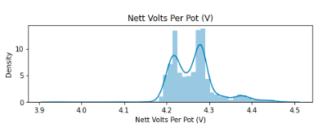

*Figure 67: Nett Volts per Plot (V)*

As in a formula, a quantity is designated by the address of its cell; it is practical to construct a dictionary of quantities, which indicates the address at which each is located. Thus translated, a rule has become executable, but also difficult to read. The measurement for Nett Volts per Plot in the graph above remains at 4.3 v.

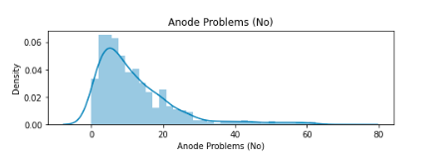

*Figure 68: Anode Problem (No)*

However, spreadsheets offer the possibility of assigning a name to a cell or to a range. It is then allowed to use this name to designate the cell or the range. The anode issue shown in the graph above has a strong trend from the outset; the reading has been unreliable, and the height of 60 is not reached until the very end, indicating that the problem really begins at 60 n.

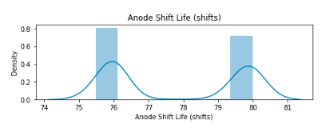

*Figure 69: Anode Shift Life (shifts)*

Another breakdown of the visible information (data and results) will be considered, no longer according to the dimensions of the model, but according to the role-played by this information. The accompanying graph provides a visual representation of the anode shift life and demonstrates the frequency uncertainty, ups and downtrend, and nature of the data.

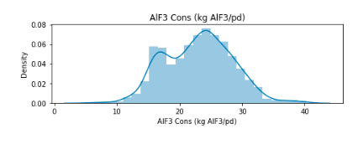

*Figure 70: AIF3 Cons (kg AIF3/pd)*

For reasons of ease of handling, the sheet may be organized in such a way that a screen contains all of the information on which the user is working. It is indeed very easy to jump from one screen to another in the four directions. The frequency rate of the data is stable, as seen by the graph AIF3 Cons kg above.

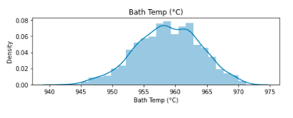

*Figure 71: Bath temp (oC)*

The data on bath temperature indicates a rise in bath temperature while dealing with various materials. All classical spreadsheets generally do not yet have mechanisms, analogous to that of procedures in third generation languages, allowing the immediate representation of the successive invocations of a sub-model for a list of data. However, it is possible to overcome this shortcoming when the spreadsheet offers the possibility of defining macros.

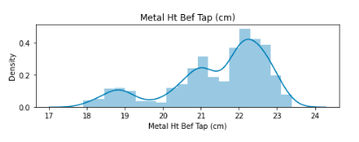

*Figure 72: Metal Ht Bef Tap (cm)*

The Metal Ht Bef Tap (cm) graph first shows a downward trend, but as it increased from 18 cm to 22 cm, it began to show an upward frequency. If the sub-model is not too complex, this technique allows an elegant implementation, although it may present important redundancies in the definitions.

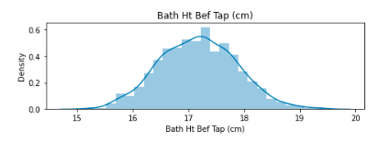

*Figure 73: Bath Ht Bef Tap (cm)*

When the sub model defines more than one result quantity, the function technique is no longer adequate, because the latter only returns a single quantity, or at best a set corresponding to a range of cells. It is always possible to replace a function with N results by N functions with one result, thanks to an explosion transformation. At the conclusion of the frequency reading, the values in the Bath HT Bef Tap graph above increase from 16 cm to 19 cm.

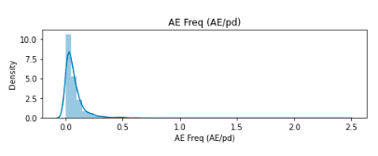

*Figure 74: AE Freq (AE/pd)*

According to the graph above, AE Frequency (AE/PD) decreased from a value of 0 to 0.5 before increasing by 2.5 at the very end. The cell representing data in the sub-model contains a formula that stores the contents of the cell corresponding to the argument of its invocation.

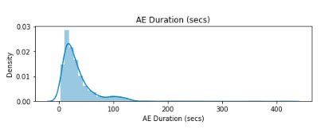

*Figure 75: AE Duration (secs)*

The frequency begins are shown on the AE duration (sec) graph above between 100 and 400 secs. The translation of a sub-model, and more generally of a model, in the form of a programmed function (EXCEL macro function for example) offers an ideal encapsulation of the internal description of the model, since this is implemented in a special sheet (macro sheet) which is invisible during execution.

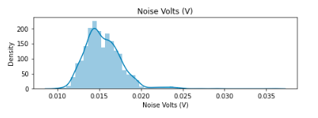

*Figure 76: Noise Volts (V)*

The graph above displays the frequency of data depending on noise, with voltages ranging from 0.015 v to 0.035 v. This fraction is the ratio between on the one hand the purchase and maintenance prices (during the depreciation period) of the unit and on the other hand the purchase and maintenance prices (same amortization period) of the complete installation.

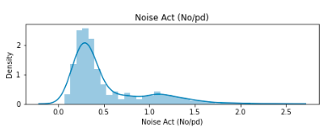

*Figure 77: Noise Act (No/pd)*

This technique is recommended when calculating the validation constraints on the data is impossible (some mathematical functions have no inverse) or impractical. There is a significant discrepancy in the frequency of noise acts in the data; first, there was an increasing trend when the data reached 2.5; however, the value dropped to 0.5, and then it increased to 2.0.

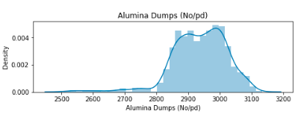

*Figure 78: Alumina Dumps (No/pd)*

The problem of the validity of the model therefore boils down to this: to prove that the admissible data D are a subset of the domain of the function F that the model constitutes. The frequency is stable, and there is a decrease trend in the alumina dump graph above, but further analysis and clarity of the data are required.

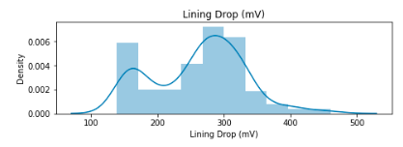

*Figure 79: Lining Drop (mV)*

These relationships are essential in validating the model where the rule appears. They make it possible to pose the conditions of validity of a rule and to propagate the calculation of the sets of values of the quantities. There are both rising and downward trends in the graph's line drop, which displays clustered bars.

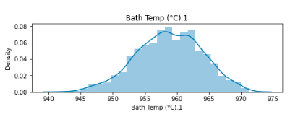

*Figure 80: Bath Temp (oC) 1*

Applications that are more complex require data whose structure is also more complex. The data is classified in several files according to the objects they describe: customer file, product file, and order file, invoice file, etc. The graph up above shows that the bath temperature began to rise at a trend of 970 and has continued to rise throughout this reading

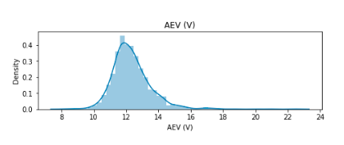

*Figure 81: AEV (V)*

It is via these links between the data that we indicate the orders that have been issued by such customer, or the products that are referenced by such order. It also appears that the data needed to an application could be useful to other applications, and even to other users. These data then constitute what is called a database. AEV is shown in the graph above; as can be seen from the data in the cell, changes occur often and quickly.

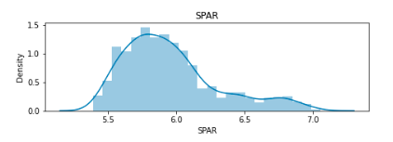

*Figure 82: SPAR*

A relational database appears as a collection of data tables, or flat files. An extremely simple and intuitive structure at least, does not encumber itself with any technical detail concerning the mechanisms of storage on disk and access to data. The temperature begins at 5.5 and rises to 7.0 at the conclusion of the measurement, as shown by the SPAR frequency.

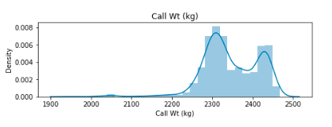

*Figure 83: Call Wt (kg)*

This language allows the user to ask the DBMS to create tables, to add columns to them, to store data in them and to modify them, to consult the data, to define the access authorizations. The weight of the material was 2400 kg before the burnout process began, it decreased somewhat, but it recovered by the conclusion of the reading. The aforementioned graph displays call weight in kg.

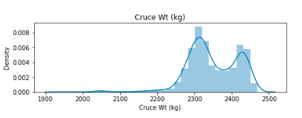

*Figure 84: Cruce Wt (kg)*

This activity is traditionally the domain of computer scientists. They not only have specific models and methods that enable them to gradually define the structures of the database, but they also use tools that help them in this activity: software workshops. The Cruce WT (kg) highs and lows are shown in the graph above; the frequency began around 2400 and persisted until the conclusion.

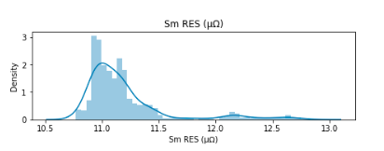

*Figure 85: Sm RES*

The analysis of the problem leads to the conceptual diagram of the database, which is an abstract solution, i.e. independent of the technology, and which is most often expressed in a graphical form of the Entity model. The frequency of the SM RES in the aforementioned graph began at 11.0 and rose to 11.5 before reaching 12.5.

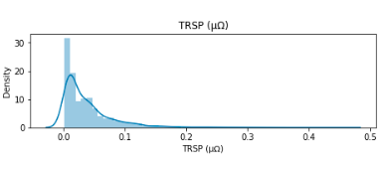

*Figure 86: TRSP*

The extraction of data from several tables, and satisfying complex conditions, will be expressed by queries that are also more complex, which require the user who formulates them to learn adequately. The frequency began at 0.0 and climbed to 0.3, as seen in the TRSP graph above.

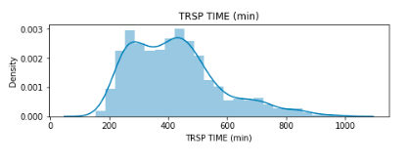

*Figure 87: TRSP (min)*

It is easy to imagine that if we want to obtain the list of localities, accompanied by the total quantities ordered by product, and ordered by decreasing number of customers whose account is negative. The TRSP Time (min) graph above illustrates the value of frequency starting at 200 and increasing to 1000 minutes at the end.

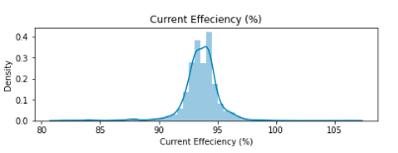

*Figure 88: Current Efficiency (%)*

The currency efficiency graph above shows data beginning at 95% and increasing to 105% at the conclusion of this reading. This stipulates that the set of values of a foreign key be at all times part of the set of values of the primary identifier of the referenced table.

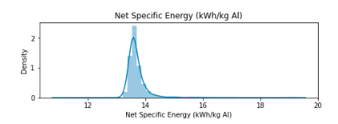

*Figure 89: Net Specific Energy (kWh/kg AI)*

The net specific energy (KWh/Kg AI) graph above begins at 14 kWh and rises to 18 kWh in the middle of the frequency before falling to 12 KWh at the very end. It is possible that information is not known at the time when the description of an entity or a fact is introduced into a table.

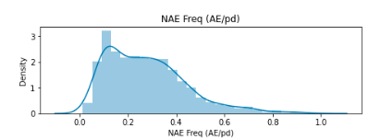

*Figure 90: NAE Freq (AE/pd)*

There are two distinct parts in a database: its schema and its content. The schema of a database defines its structure in terms of tables, columns (with the type of values and the mandatory or optional nature of each), primary and secondary identifiers, and foreign keys. The NAE Freq in the graph above begins at 0.2 and increases to 1.0 at the conclusion of this frequency measurement.

## 4.8. Scaling data using box plot

The five-number summary of a data set is shown in a box and whisker plot, sometimes referred to as a box plot. The five-number summary includes the minimum, first quartile, median, third quartile, and maximum. In a box plot, a box is drawn from the first to the third quartile. A vertical line cuts through the box at the median. The whiskers of each quartile point to the minimum or maximum. The data extracted using python is presented below,

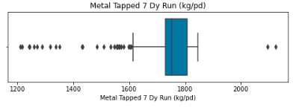

*Figure 91: Metal Tapped Dy Run (kg/pd)*

The graph above demonstrates the variation in the metal that was tapped at Dy Run 7; the bulk of the reasons are given as 1800, which decreased to 1400, and afterwards attain constant growth rate in the burning of aluminium.

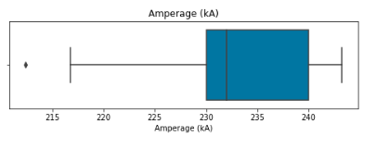

*Figure 92: Amperage (kA)*

The accompanying graph illustrates the fluctuating frequency of amperage (KA). The frequency bounces up and down at various points, but eventually falls to 220. A table is represented by a box with three compartments successively indicating the name of the table, the name of its columns and the integrity constraints.

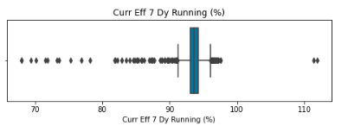

*Figure 93: Curr Eff 7 Dy Running (%)*

The frequency trend for Curr Eff 7 Dy may be seen in the graph above as a straight line. Running, it dipped to 70% at one point, but by the conclusion of the reading, it had begun to recover control and was at 110% A scheme that includes an identifier consisting of two (or more) foreign keys must be the subject of very special attention when this identifier is itself targeted by a foreign key.

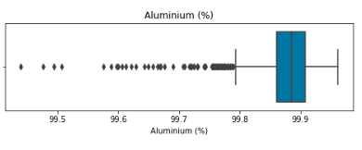

*Figure 94: Aluminum (%)*

There is a thick downward trend in the proportion at which aluminium burns indicating that it needs further thought. A table is normalized if every determinant in it is an identifier. Conversely, if a table is the seat of an abnormal functional dependency, that is to say, whose determinant is not an identifier, and then this table is not normalized, and is likely to contain redundant data.

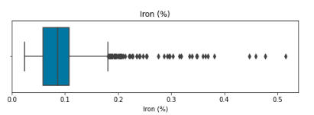

*Figure 95: Iron (%)*

There are several techniques for making an index. One of them comprises a correspondence table, which associates, with each value of the column, or columns, the list of numbers of the corresponding rows. In this correspondence table, the column values are arranged in ascending or descending order. The aforementioned graph illustrates how often iron reacts to temperature; although there is a brief rising trend, generally, the percentage at which the temperature of iron is maintained remains steady.

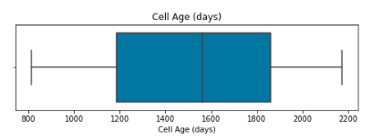

*Figure 96: Cell Age (days)*

This designation of datasets takes the form of SQL queries. The result of a query comes in the form of a table, possibly of a single row and/or a single column. The data in this table is usually retrieved from the database. The cell age in days is shown to have increased steadily from 750 to 2000 before beginning to decline. The trend line is created using a straight line that displays the cell's high value data.

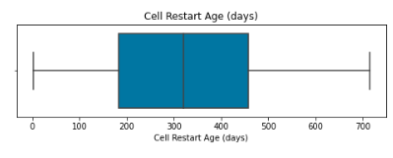

*Figure 97: Cell Restart Age (days)*

A value beginning with any other character is considered a label. A label is a value that can be manipulated by string processing functions. It should be noted that the symbol ' (apostrophe) in the first position is not considered as a character, but as the indication of a label. After the cells were restarted, the pattern changed; the number increases from zero to 600 before trending downward to 400.

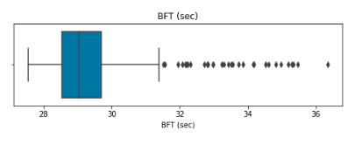

*Figure 98: BFT (sec)*

A cell is designated by its address. A range will be by the addresses of a diagonal: B3:D5. Any cell or range can be given a name by which it can be referred to. The use of this name allows the construction of more readable formulas. As with previous temperature measurements, the frequency at which BFT sec is operating has steadily increased, and the burn rate has remained constant.

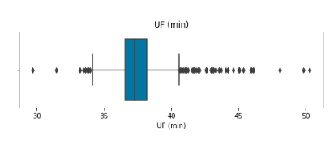

*Figure 99: UF (min)*

Given a table, or more generally a model, already created, it may be necessary to modify its structure and appearance in order to extend it or improve its readability. The UF reading (per minute) has been increasing from the beginning; the fluctuations in frequency are visible as they go upward, but the reading has just reached its highest point after 45 minutes. 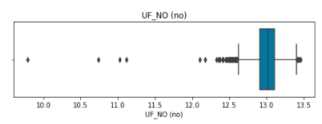

*Figure 100: UF_NO (no)n m,l;ko*

The ratios are displayed in a decreasing trend and display a negative value, as seen in the UF NO noticed in this figure. The copy operation makes a copy of the contents of a range to another location on the sheet. The original range may shrink to a single cell, which will be the most common case.

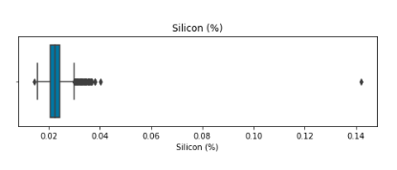

*Figure 101: Silicon (%)*

The rate at which silicon burns is steady and does not rise over 0.25%; although, at one time, it reached.125percentage, before returning to its previous level. There are possibilities of copying with variants: copying not the formulas, but the result of their evaluation, copying by adding or subtracting the copied values to the old values rather than replacing them (Special copy).

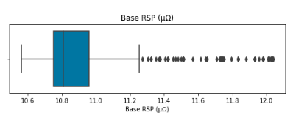

*Figure 102: Base RSP*

The graph above explores the frequency value of the cell data's base RSP indicates a steady condition, but often the number ends up showing a height. We propose to complete the text of the statement by indicating the names of the quantities that this text suggests, as well as their dimensions

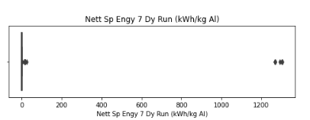

*Figure 103: Nett Sp Engy 7 Dy Run (kWh/kg AI)*

The "Nett SP Engy 7 Dy Run" graph above indicates a value of zero for the whole period, yet it increased at five points, reaching 1250. The expression of the calculation formulas is more reliable and more readable.

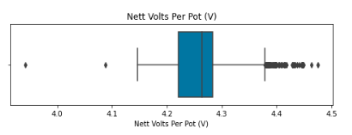

*Figure 104: Nett Volts per Plot (V)*

The measurement for Nett Volts per Plot in the graph above remains at 4.3 v. Although it is foreign to the operation of the table (it only intervenes when setting up the table in a spreadsheet), the concept of relative address poses some problems for the beginner modeller and deserves attention.

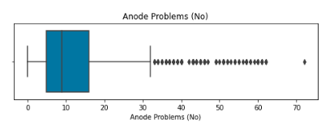

*Figure 105: Anode Problem (No)*

The anode issue shown in the graph above has a strong trend from the outset; the reading has been unreliable, and the height of 60 is not reached until the very end, indicating that the problem really begins at 60 n.

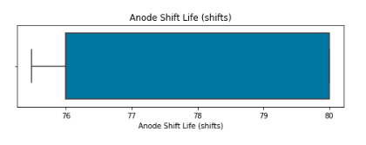

*Figure 106: Anode Shift Life (shifts)*

The accompanying graph provides a visual representation of the anode shift life and demonstrates the frequency uncertainty, ups and downtrend, and nature of the data. It consists of protecting the derived quantities, which risk being assigned the error value by a precondition on the domain of values of their definition rules.

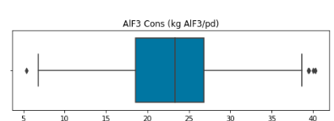

*Figure 107: AIF3 Cons (kg AIF3/pd)*

The frequency rate of the data is stable, as seen by the graph AIF3 Cons kg ALF3 above. The calculation formula is identical, mutatis mutandis, in all cells B4:D6; it expresses that the amount at the end of the year is equal to that of the previous year plus interest

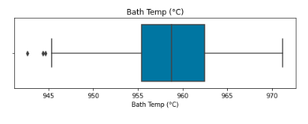

*Figure 108: Bath temp (oC)*

The data on bath temperature indicates a rise in bath temperature while dealing with various materials. The copy operation makes a copy of the contents of a range to another location on the sheet. The original range may shrink to a single cell, which will be the most common case.

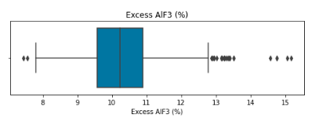

*Figure 109: Excess AIF3 (%)*

A numeric value can be treated as a logical value: zero is interpreted as false and any non-zero value as true. On the other hand, a logical value has no numerical equivalent. The Metal Ht Bef Tap (cm) graph first shows a downward trend, but as it increased from 18 cm to 22 cm, it began to show an upward frequency.

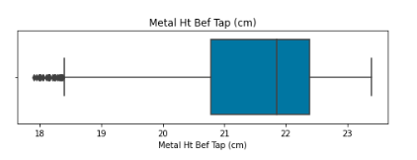

*Figure 110: Metal Ht Bef Tap (cm)*

At the conclusion of the frequency reading, the values in the Bath HT Bef Tap graph above increase from 16 cm to 19 cm. The move operation is used to restructure a table by moving ranges. If a formula contains relative or absolute addresses pointing to cells in the moved range, it will be automatically adjusted.

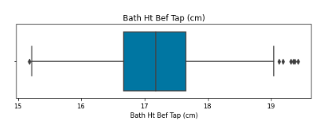

*Figure 111: Bath Ht Bef Tap (cm)*

The second format (quoted for memory) corresponds to a mode of use in which one wishes to see only one value of the series at the same time, the calculation of the value next being controlled by a new activation of the model.

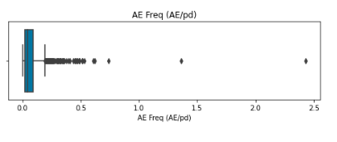

*Figure 112: AE Freq (AE/pd)*

According to the graph above, AE Frequency (AE/PD) decreased from a value of 0 to 0.5 before increasing by 2.5 at the very end. It is also possible to define conditional expressions, using the function. The arguments of this function form a list of three expressions.

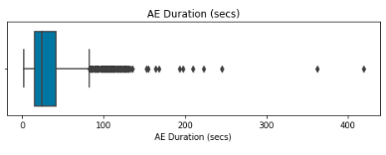

*Figure 113: AE duration (sec)*

A sequence of characters that begins with a digit, possibly preceded by a + or a -, is interpreted as a numeric value. The frequency begins are shown on the AE duration (sec) graph above between 100 and 400 secs.

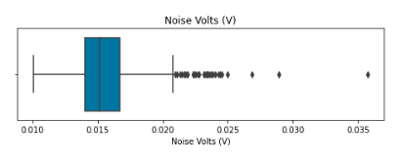

*Figure 114: Noise Volts (V)*

Any displayable character is introduced into the current cell. The key or a movement of the cursor terminates the entry. The graph above displays the frequency of data depending on noise, with voltages ranging from 0.015 v to 0.035 v.

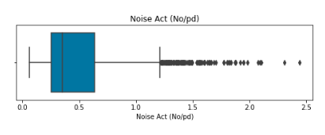

*Figure 115: Noise Act (No/Pd)*

There is a significant discrepancy in the frequency of noise acts in the data; first, there was an increasing trend when the data reached 2.5; however, the value dropped to 0.5, and then it increased to 2.0.

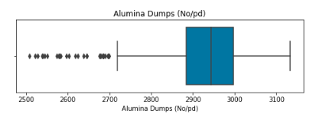

*Figure 116: Alumina Dumps (No/pd)*

The frequency is stable, and there is a decrease trend in the alumina dump graph above, but further analysis and clarity of the data are required. There are links between the files, which reflect the relationships between the objects described.

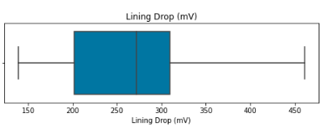

*Figure 117: Lining Drop (mV)*

The designer defines the vertical and horizontal hierarchical groups of his table (he indicates for example the sales then their total). He can then ask to see only the plan that is to say to hide the levels below a determined level. There are both rising and downward trends in the graph's line drop, which displays clustered bars.

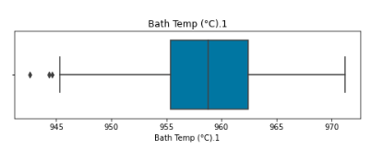

*Figure 118: Bath Temp (oC) 1*

The graph up above shows that the bath temperature began to rise at a trend of 970 and has continued to rise throughout this reading

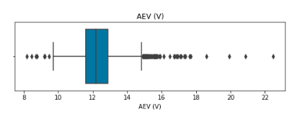

*Figure 119: AEV (V)*

AEV is shown in the graph above; as can be seen from the data in the cell, changes occur often and quickly.

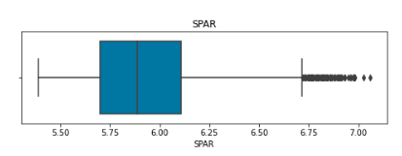

*Figure 120: SPAR*

The temperature begins at 5.5 and rises to 7.0 at the conclusion of the measurement, as shown by the SPAR frequency.

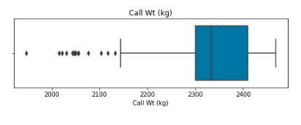

*Figure 121: Call Wt (kg)*

The weight of the material was 2400 kg before the burnout process began, it decreased somewhat, but it recovered by the conclusion of the reading. The aforementioned graph displays call weight in kg.

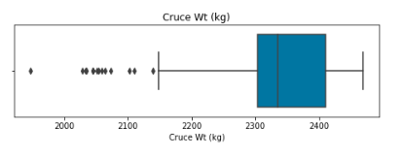

*Figure 122: Cruce WT (kg)*

The Cruce WT (kg) highs and lows are shown in the graph above; the frequency began around 2400 and persisted until the conclusion.

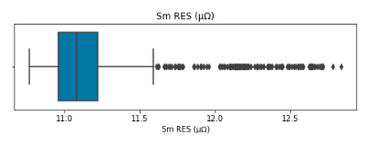

*Figure 123: SM RES*

The frequency of the SM RES in the aforementioned graph began at 11.0 and rose to 11.5 before reaching 12.5.

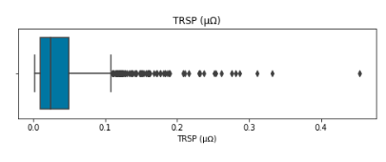

*Figure 124: TRSP*

The frequency began at 0.0 and climbed to 0.3, as seen in the TRSP graph above.

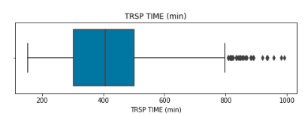

*Figure 125: TRSP Time (min)*

The TRSP Time (min) graph above illustrates the value of frequency starting at 200 and increasing to 1000 minutes at the end.

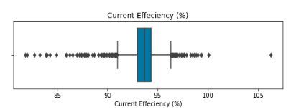

*Figure 126: Current Efficiency (%)*

The currency efficiency graph above shows data beginning at 95% and increasing to 105% at the conclusion of this reading. . The locations of probable outliers are shown on the figure by tiny circles or blank areas with full circles, known outliers.

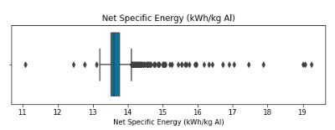

*Figure 127: Net Specific Energy (KWh/Kg AI)*

The net specific energy (KWh/Kg AI) graph above begins at 14 kWh and rises to 18 kWh in the middle of the frequency before falling to 12 KWh at the very end. If there are outliers, 1.5 * IQR is drawn instead of the minimum or maximum value of the data on the corresponding side.

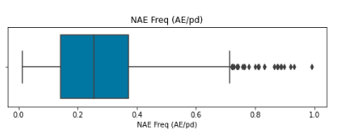

*Figure 128: NAE Freq (AE/pd)*

The NAE Freq in the graph above begins at 0.2 and increases to 1.0 at the conclusion of this frequency measurement. Sometimes, outliers that are considered anomalies might be identified in data sets (perhaps because of data collection errors or just plain old flukes).

## 4.9. ARIMA Model

Two families of econometric models that are often cited in academic work and used to forecast financial prices are discussed. On one hand, models of the Seasonal-ARIMA or SARIMA type are used. However, owing to the indication of conditional heteroscedasticity revealed in the squared residuals of the aforementioned model, GARCH-type structures are included. As a result, SARIMA-GARCH models will make up the second category of estimated models. Additionally, two methods will be used to estimate the prior models: from the original series and from the constitutive series generated after determining the impact of operational modifications in aluminium smelting on bath overflow and burn-off.

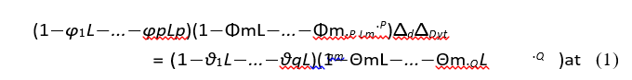

*Figure 129: Calculation Equation*

where p, d, and q stand for the model's moving average (MA) order, the differentiation order required to ensure stationary in the series, and the autoregressive order (AR), respectively. P, D, and Q are used to represent the orders of the model's seasonal component, where m is the duration of the seasonal period under consideration. Additionally, the coefficients for the lags of the AR and MA orders are represented by and, respectively, while the coefficients for the model's seasonal AR and MA orders are represented by and. Last but not least, atis the residual of the model, for which we assume a distribution N (0, 2), and L represents the delay operator (d D ytj = d D YT Lj).

When the series being modelled are stationary in mean and variance, as is the case for the series in simple differences, the parameter d will always equal zero. But when dealing with the series produced by the Wavelet Transformation, it can be different from zero. For each of the series under consideration, the models that minimize the Akaike Information Criterion (AIC) are chosen as the order of the model to be employed. The parameter m, on the other hand, is selected in accordance with the simple and partial autocorrelation functions (ACF and PACF, respectively) seen in each example.

**Decision Tree Regressor**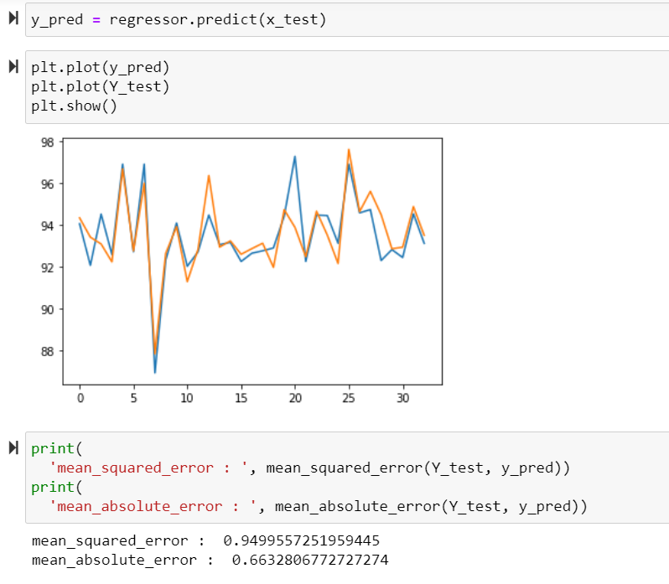

**LSTM**

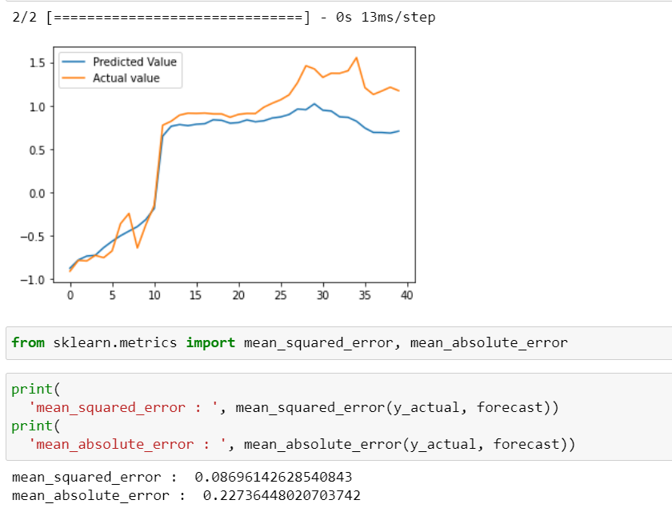

**REGRESSION**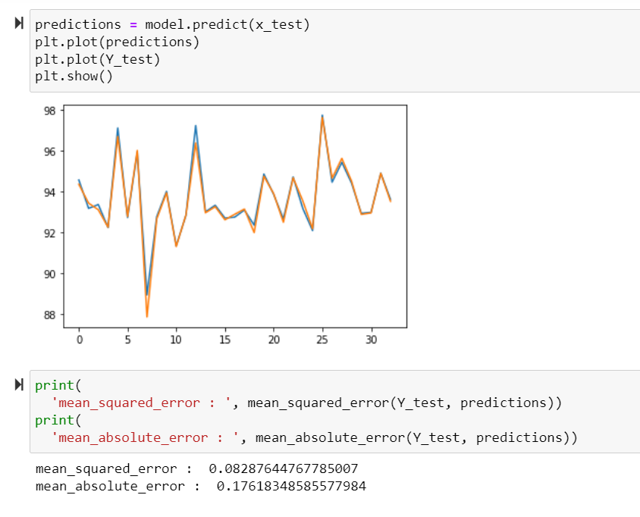

**RNN**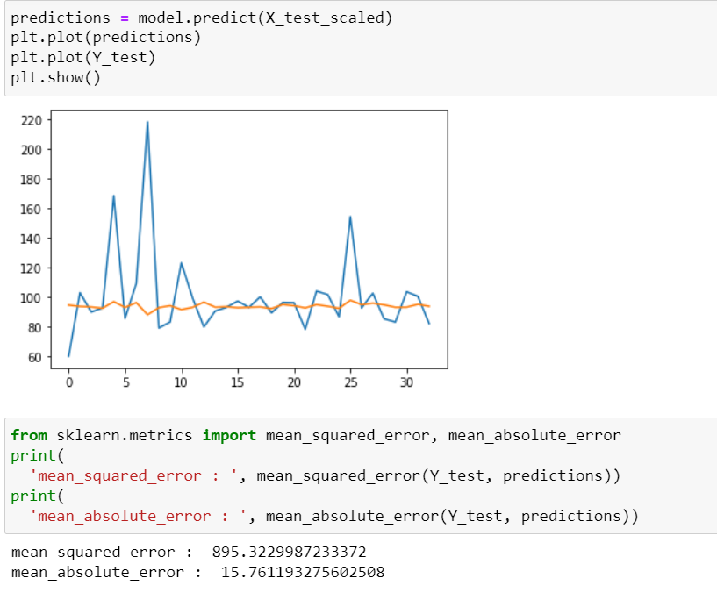

**SARIMA**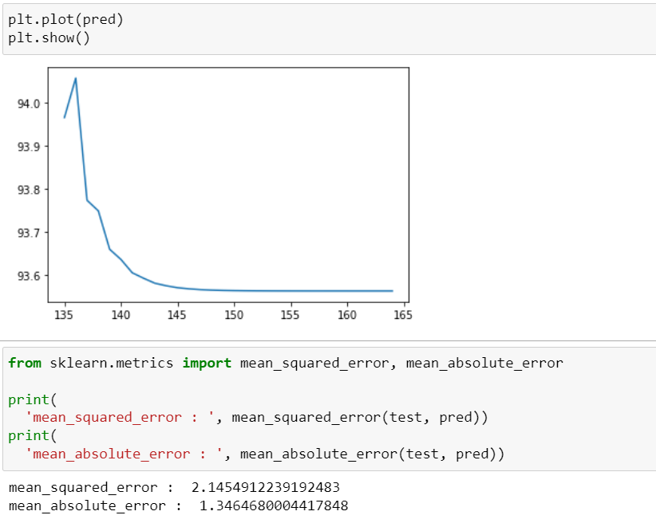

**ARIMA**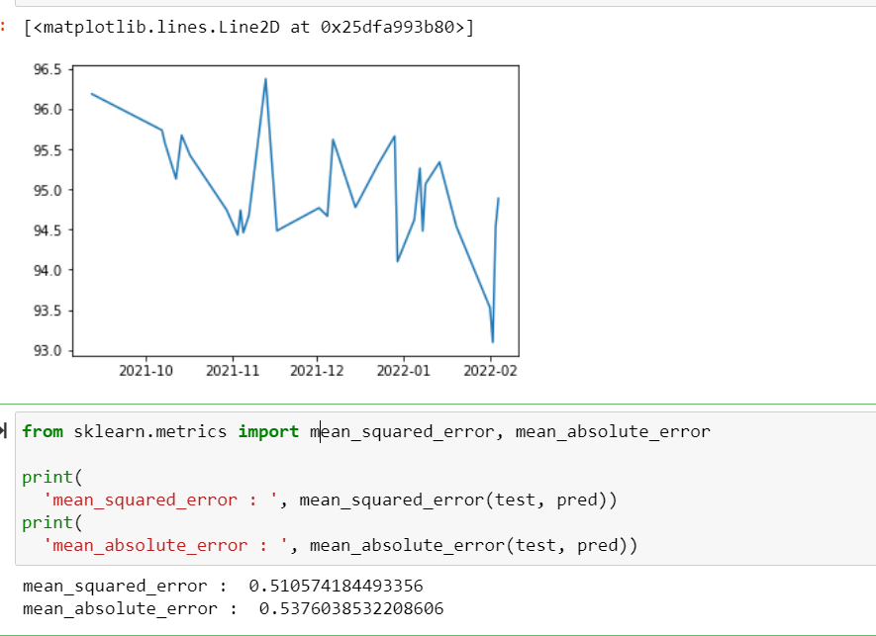

**COMPARISON TABLE**

| **MODEL NAME** | **MEAN SQUARED ERROR** | **MEAN ABSOLUTE ERROR** |
| --- | --- | --- |
| **DECISION TREE REGRESSOR** | 0.94995572 | 0.66328067 |
| **LSTM** | **0.08696142** | **0.22736448** |
| **REGRESSION** | **0.08287644** | **0.17618348** |
| **RNN** | 895.322998 | 15.7611932 |
| **SARIMA** | 2.14549122 | 1.34646800 |
| **ARIMA** | 0.51057418 | 0.53760385 |

As per the graphs generated by the 6 forecast models, out of them, two are time series models. The following models are developed here, decision tree regressor, LSTM, Regression, RNN, SARIMA, ARIMA. Out of them, SARIMA and ARIMA are timeseries forecast models. The worst performing model here is the RNN model which gives a mean squared error of 895.322998, and mean absolute error of 15.7611932. The best performing models are firstly, Regression which has a mean squared error of 0.08287644 and mean absolute error of 0.17618348, and secondly the LSTM which has a mean squared error value of 0.08696142 and mean absolute error of 0.22736448.

# Chapter 5: Conclusion

## 5.0. Conclusion

The anode effect (AE), which lowers aluminium production and quality, is a significant problem in the smelting of aluminium. A quick increase in voltage and a subsequent drop in amperage are both symptoms of AE, which is the polarisation of anodes during the electrolysis of fused salts. The main cause of the AE is the depletion of oxygen-containing species at the surface of the carbon anodes during the smelting of aluminium. The anode becomes polarised as a result. When the alumina content is too low, the anode effect also occurs. Sparking occurs around the anode as a result of the anode being moist and the voltage rising. The electro-capillary effect occurs when alumina is depleted because of a rise in bath surface tension and voltage. High anode overvoltage is what causes the high electro-capillary effect. This process lowers the anode's wetting, which lowers the contact angle of the bubbles, leading to the formation of big bubbles. Before AE, the alumina content often falls to 30% of its normal level. As a result, the oxygen-containing ions approach the anode at a pace that is 2/3 of their typical rate. Once the resistive layer has developed on the anode's surface, either the voltage is raised while maintaining a constant current or the current is lowered while maintaining a constant voltage.

When the anodic current density (ACD) reaches the critical current density, the AE occurs (CCD). The latter depends on the amperage, anode size, and dissolved alumina content in solution. Electrolyte flow, gas bubble generation, temperature, and anode spacing all play a role in the AE. The anode effect is caused by the local alumina depletion that results from the early worsening of the wetting and increased gas bubble coverage, which increases the current density at the active regions of the anode. The co-discharge of fluorocarbons at the anode surface produces carbon fluoride intermediates, which have a strong dewetting action and result in high voltage and the synthesis of fluorides. Consumable carbon anodes have a number of drawbacks.

A 0.5V overvoltage also produces carbon impurities, which are eventually incorporated into the electrolysis process. Fluorine bonds with carbon when the overvoltage is around 1.2V. These substances have low surface energies, which leads to increased dewetting and the development of big bubbles. Therefore, during the AE, an ongoing gas film forms on the anode and electrolyte solution. To lessen the anode impact, many adjustments have been made to the anode, the anode, and the overall bath parameters. For instance, coke, binder pitch, and paste materials have been used in the creation of non-consumable anodes.

By lowering the wettability of the molten bath, paste materials based on lithium compounds reduce the overvoltage at the anode. On the other hand, a number of writers have found anodic overvoltage’s that are 200mV lower when electro catalytic dopants are utilized in anode reactions. The economy of smelters and the smelting process as a whole might be greatly enhanced by altering the anode's proportions and relative location. For instance, compared to the anodes upstream, the ones on the pot ends and downstream experienced larger burn-offs as it is seen throughout the results.

**References**

1. Alzamani, M., Jafarzadeh, K., & Fattah-alhosseini, A. (2021). Development of lanthanum doped Ni10Cu11Fe6Al as a new inert anode in molten salt calcium chloride for titanium oxide electrolysis. *Journal of Alloys and Compounds*, *876*, 159997.
2. Brisson, P.-Y.; Darmstadt, H.; Fafard, M.; Adnot, A.; Servant, G.; Soucy, G. (2006). "X-ray photoelectron spectroscopy study of sodium reactions in carbon cathode blocks of aluminium oxide reduction cells". *Carbon*. 44 (8), 1438–1447.
3. Chen, G. Z. (2020). Interactions of molten salts with cathode products in the FFC Cambridge Process. *International Journal of Minerals, Metallurgy and Materials*, *27*(12), 1572-1587.
4. Fini, M. F., Soucy, G., Désilets, M., Lombard, D., Pelletier, P., & Paulus, R. (2020). Chemically induced sludge formation in Hall-Héroult process. *Minerals Engineering*, *156*, 106527.
5. Galasiu I, Galasiu R, Thonstad J. (2007) *Inert Anodes for Aluminium Electrolysis*. Düsseldorf, Germany: Aluminium-Verlag, Marketing & Kommunikation GmbH; 1–207
6. Haarberg, G. M., Khalaghi, B., & Mokkelbost, T. (2016). Natural gas anodes for aluminium electrolysis in molten fluorides. *Faraday Discussions*, *190*, 71-84.
7. Haraldsson, J., & Johansson, M. T. (2018). Review of measures for improved energy efficiency in production-related processes in the aluminium industry–From electrolysis to recycling. *Renewable and Sustainable Energy Reviews*, *93*, 525-548.
8. Haraldsson, J., & Johansson, M. T. (2020). Effects on primary energy use, greenhouse gas emissions and related costs from improving energy end-use efficiency in the electrolysis in primary aluminium production. *Energy Efficiency*, *13*(7), 1299-1314.
9. Halpin W & Seger E (2013) Aiming for Zero Anode Effects Essential Readings in Light Metals: Aluminum Reduction Technology
10. Jahedi, Mahnaz & Oh, Anselm & Gulizia, Enzo & Gulizia, Stefan & Malallah, Ali & Jallaf, Maryam & Jabbri, Najeeba & Zarouni, Ali. (2009). Anode coating to prevent airburn in aluminium smelters. TMS Annual Meeting.
11. Kjos, O. S., Solheim, A., Aarhaug, T., Osen, K. S., Martinez, A. M., Sommerseth, C., ... & Gaertner, H. (2018, March). PFC evolution characteristics during aluminium and rare earth electrolysis. In *TMS Annual Meeting & Exhibition* (pp. 1449-1455). Springer, Cham.
12. Kuang, Z.; Thonstad, J.; Rolseth, S.; Sørlie, M. (1996). "Effect of baking temperature and anode current density on anode carbon consumption". *Metallurgical and Materials Transactions B*. 27 (2), 177–183.
13. Kvande, H., & Drabløs, P. A. (2014). The aluminum smelting process and innovative alternative technologies. *Journal of occupational and environmental medicine*, *56*(5 Suppl), S23–S32. <https://doi.org/10.1097/JOM.0000000000000062>
14. Li, M., Wang, J., Hou, W., Cheng, B., & Li, H. (2021). Mathematical model of the dissolution process of alumina particles in the Hall-Héroult process. *International Communications in Heat and Mass Transfer*, *128*, 105627.
15. Li, W., Gao, Y., Ma, Z., Gao, L., Wei, C., Wang, F., ... & Li, H. (2020). Comparison thermochemical and thermophysical performances analysis in laser processing by dynamic heat-matter diffusion coupling simulation and corresponding experiment validation. *Ceramics International*, *46*(3), 3066-3073.
16. Ming-yin, K. O. U., Ming-Yong, W. A. N. G., & Shu-Qiang, J. I. A. O. (2021). Inert anode in a high-temperature molten salt system and oxygen generation by moon regolith electrolysis. *43*(12), 1618-1629.
17. Prasad, S (2000)The principal problems of aluminum electrowinning: an update, Braz. J. Chem. Eng. 17 (2)
18. Tableaux, A & Peterson, R (2014) [Aluminum Production](https://www.sciencedirect.com/science/article/pii/B9780080969886000237), [Treatise on Process Metallurgy: Industrial Processes](https://www.sciencedirect.com/book/9780080969886/treatise-on-process-metallurgy)
19. White CV, Mikkelsen Ø, Roha D (2012). Status of the Alcoa carbothermic aluminum project. In: Downey JP, Battle TP, White JF, eds. *International Smelting Technology Symposium (Incorporating the 6th Advances in Sulfide Smelting Symposium)*. San Antonio, TX: TMS (The Minerals, Metals and Materials Society); 81–88